**ECE6370**

### Final Project: A FPGA enabled multiuser rapid math game “The Last of Us”

Team UNAGI2.0

**Contents**

|  |  |
| --- | --- |
| Section | Page Number |
| 1.1 Introduction | 2 |
| 1.2 System Architecture Design  1.2.1 Modules | 3  4 |
| 1.3 Simulation Results | 18  20 |
| 1.4 Conclusion  1.5Appendix | 21 |
|  |  |
|  |  |
|  |  |
|  |  |

* 1. **Introduction**

The proposed FPGA game is a multi-user authentication game inspired by the series "The Last of Us". The player is required to solve a given question within a set time limit, failing which, a fungi will spread, indicated by the LED lights.

The game has three levels, and in each level, the player is required to shift each generated random number with the key and add the resultant numbers after the shift which would result in a two-digit number. The player needs to input the correct value within the given time limit, failing which, an LED will turn on i.e., the fungi spreads. The objective of the game is to break the spread of the fungi i.e., turn off all the LEDs before the time limit expires.

The game also features score tracking, where the player's score is equivalent to their health. Starting at 51 %, the player's health increases by 10 % from level one to level two and by 20 % from level two to level three and increasing by 1% for every correct answer, decreases for every incorrect answer ultimately reaching a maximum of 99 % when the player passes level three. After completing the game, the player can view their personal and global best scores.

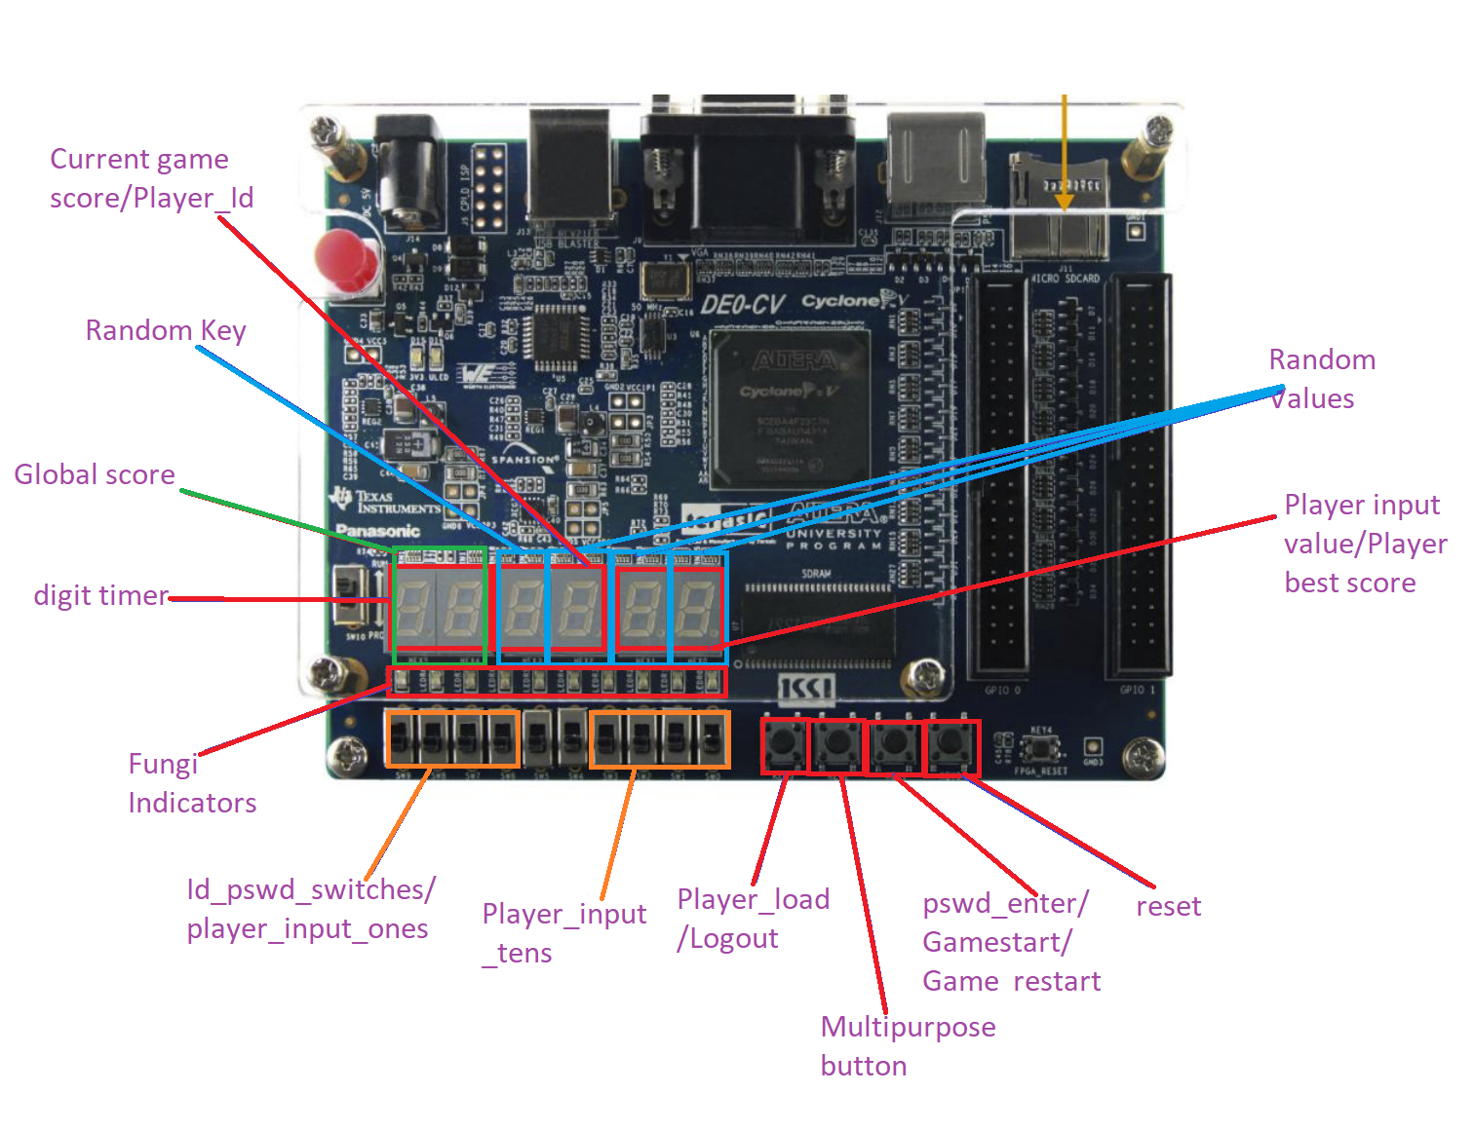

* 1. **System Architecture**

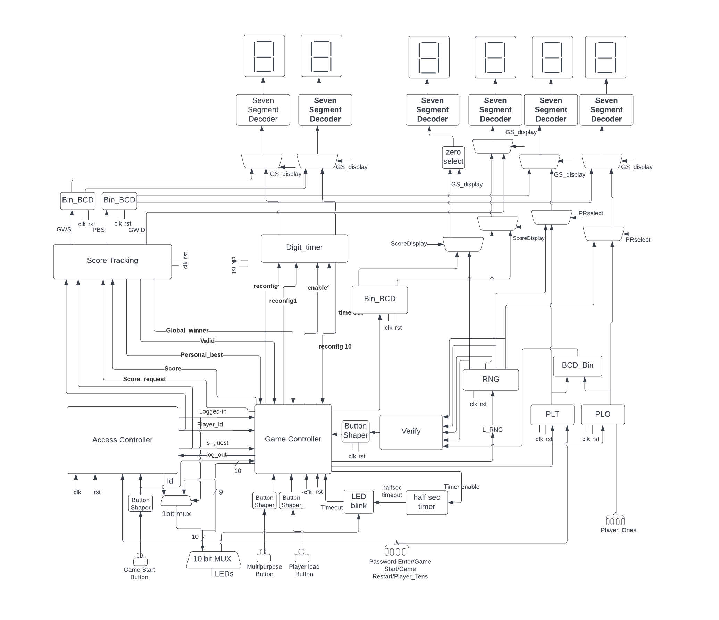

**1.2.1 Modules:**

1. **Seven Segment Decoder:**

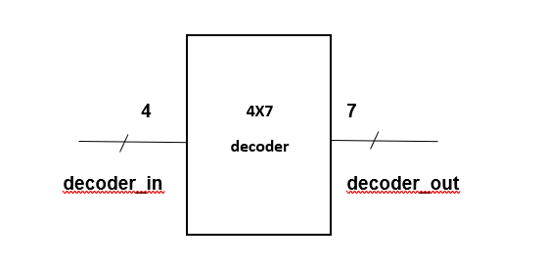

* The seven-segment decoder converts our 4-bit input signal to 7-bit output signal so that we can access the seven-segment display and display upto 16 combinations of inputs i.e., 0 to F numbers in hex.
* To display the numbers on the seven-segment display, we need to figure out which of the 7 segments need to be turned on/off and assign the outputs to inputs in corresponding manner.
* For example, to display 8, while the input bits are 1000, all the 7 segments need to be turned on in order to display 8 which makes the output to be 0000000, since the seven-segment display turns on by low logic level.

1. **Button Shaper**

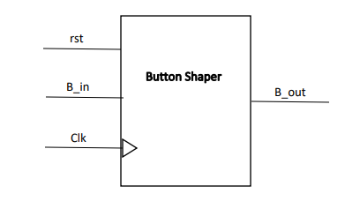

* A button shaper module is designed to give a single pulse input to the load register.
* It has 3 inputs, rst, B_in, Clk and 1 output B_out.
* The rst is RESET signal which is active low. Whenever the rst is active, the Button Shaper goes back to initial state.
* When the user presses a button, it activates the B_in signal, which is also an active low signal. This produces a single pulse signal B_out.
* The single pulse B_out is then given as input to the load register as the LOAD input, so that the register can successfully store the User’s inputs.
* Clk is the Clock signal.
* **Finite State Machine :**

|  |  |  |  |
| --- | --- | --- | --- |
|  |  |  |  |
|  |  | | |
|  |  |  |  |
|  |  |  |  |

* 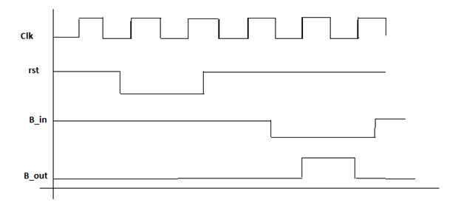**Expected Waveforms:**

**4.Load Register:**

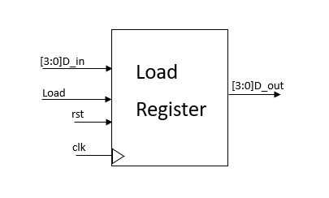

* The Load Register is just a basic register with and added signal of Load.
* Like a normal register it stores input values, D_in, and sends it as output, D_out.
* But the output is active only when there is 1 single high ‘Load’ pulse.
* The clk is the clock signal and rst is the reset signal.

**5.VERIFY MODULE:**

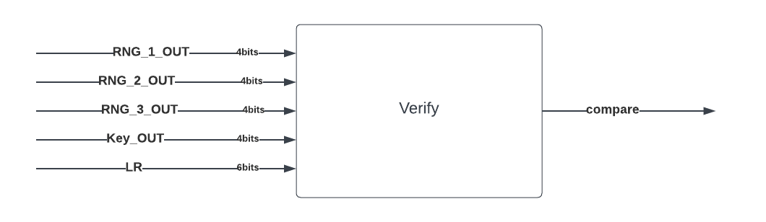

* This module calculates sum of the three 4 bit Hex random numbers which are shifted by a value of key and compares this value with the player entered value and generates a signal, compare indicating whether both are equal or not.
* This module has 5 inputs namely, RNG_1_OUT(4bits), RNG_2_OUT(4bits), RNG_3_OUT(4bits), Key_OUT(4bits) coming from RNG_Project module and LR(6bits[Player entered value]) coming from the BCD_Binary module.

**6.Binary to BCD:**

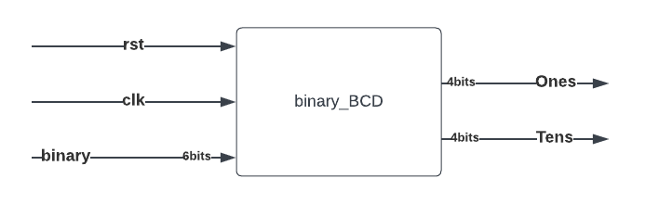

binary_BCD:This module converts a binary number to a BCD number. This is a sequential module with inputs-rst(reset), clk(clock), binary(6bits) and outputs-Ones(4bits), Tens(4bits).

**7.BCD_Binary:**

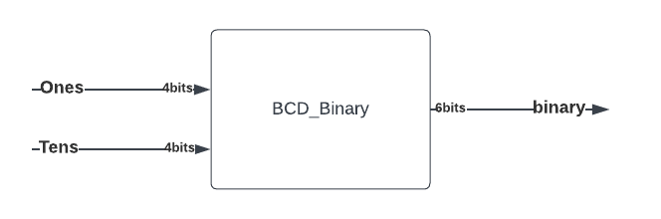

BCD_Binary:This module converts two digit BCD into it’s corresponding binary number. This combinational module has two inputs- Ones(4bits), Tens(4bits) indicating ones digit and tens digit respectively and one output- binary(6bits).

**8.Access Controller:**

This module is responsible for two step verification of the player. This internally has 4 daughter modules of which 2 are ROMs for storing the ID and Password for each player, the other 2 are IDcheck(for checking the player enterd ID with the ID stored in the ROM_ID) and Pswdcheck(for checking the player entered password with the password stored in the PSWD_ID). This module has clk, rst, Player_ID_PSWD(4bits), ID_PSWD_Enter, Logout as inputs and Player_InternalID(4bits) , LoggedIn, isGuest, IDmatched as outputs. The communication between IDCheck module and ROM_ID module is through ID_ROMaddr and ID_ROMData. The communication between Pswdcheck and PSWD_ID is PSWD_ROM_addr and PSWD_ROM_data. IDCheck module sends Player_ID_PSWD, Internal_Player_ID, isGuestIDtoPSWD, IDmatched_toPSWD to Pswdcheck module and receives Logout_PSWDtoID from it.

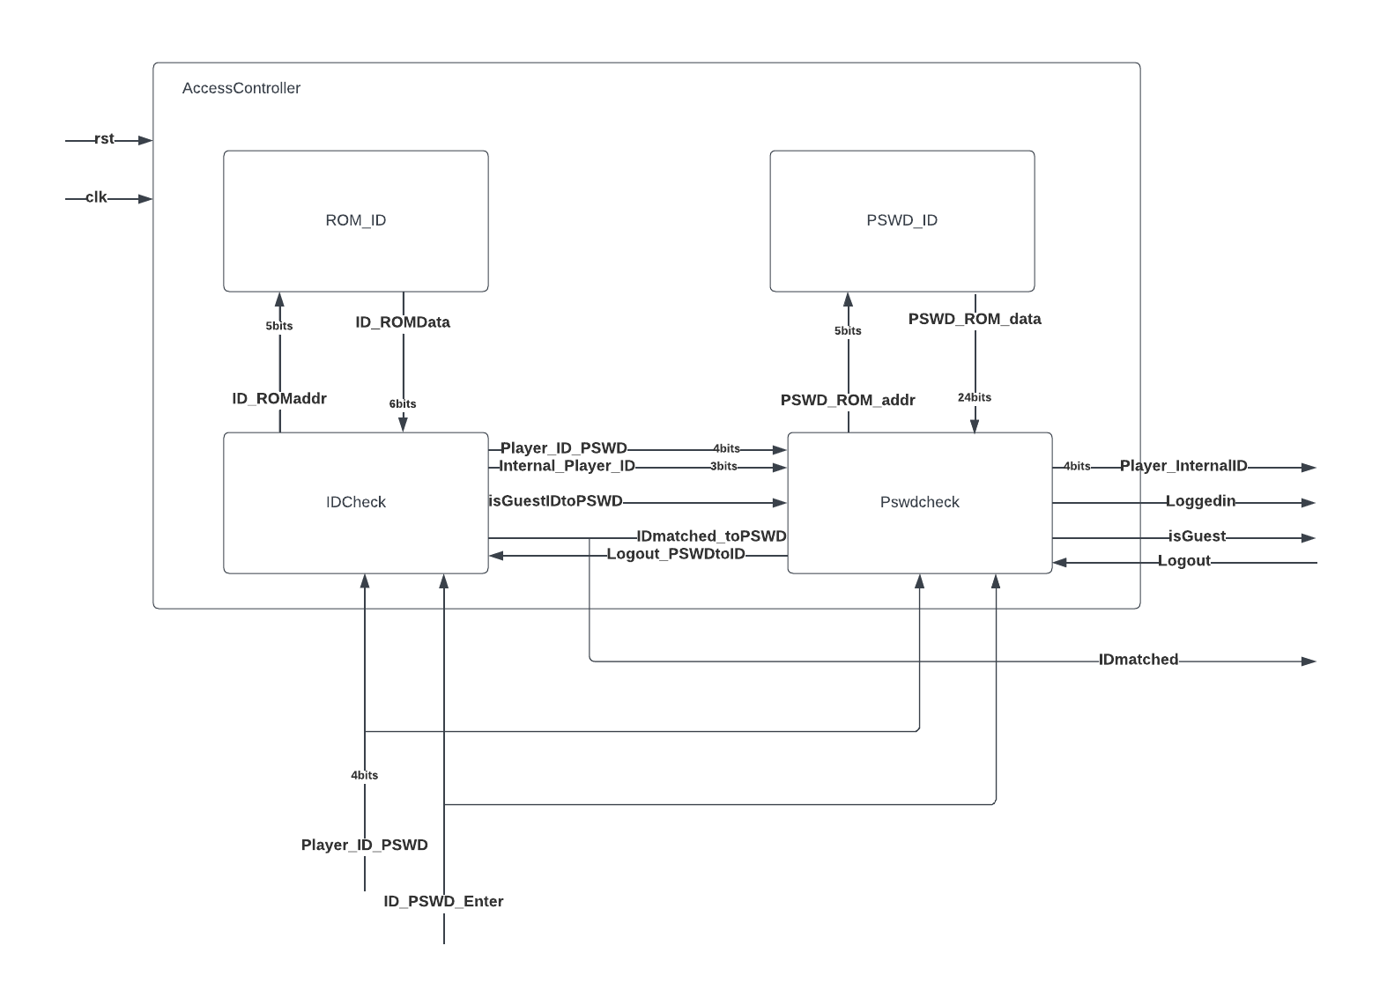

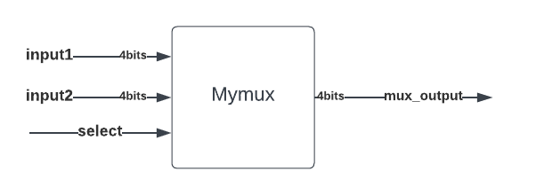**9.Multiplexer:**

* 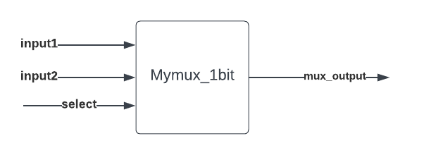Mymux(_1bit) module is a combinational multiplexer module with inputs- input1, input2, select and output- mux_output. This module sends either inpu1 or input2 as mux_output based on the select value. When select is 1’b1, mux_output=input2, and when select is 1’b0, mux_output=input1.
* As shown in the above pictures , we have used similar mux with 7 bit and 10 bit.

**10.Random Number Generator:**

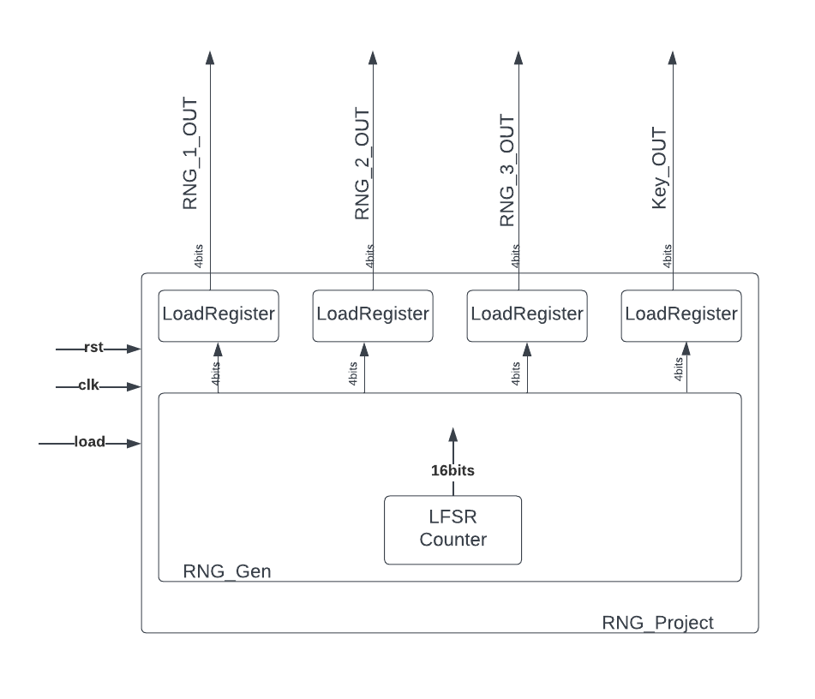

**11.RNG_Project:** This module is responsible for generating the 3 random numbers(4 bit) and the key(3 bit), for the gameplay. This module internally has daughter modules called LoadRegister and RNG_Gen.

**12.LoadRegister**: This stores the random number generated by RNG_Gen module and gives the same as output when it receives a load signal from the game controller module.

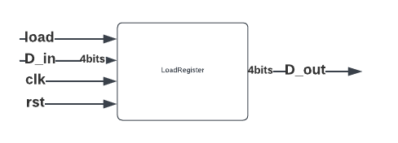

**13.RNG_Gen module:** This module internally has a 16 bit LFSR counter which generates a 16bit random number. This random number is used for the generation of the 4 different 4bit numbers. Here we used bits {0,1,3,2} for RNG_1, bits {6,7,5,4} for RNG_2, bits {12,13,15,14} for RNG_3 and bits {8,9,11,10} for Key generation.

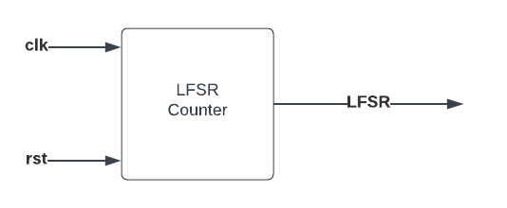

**14.Score Tracking:**

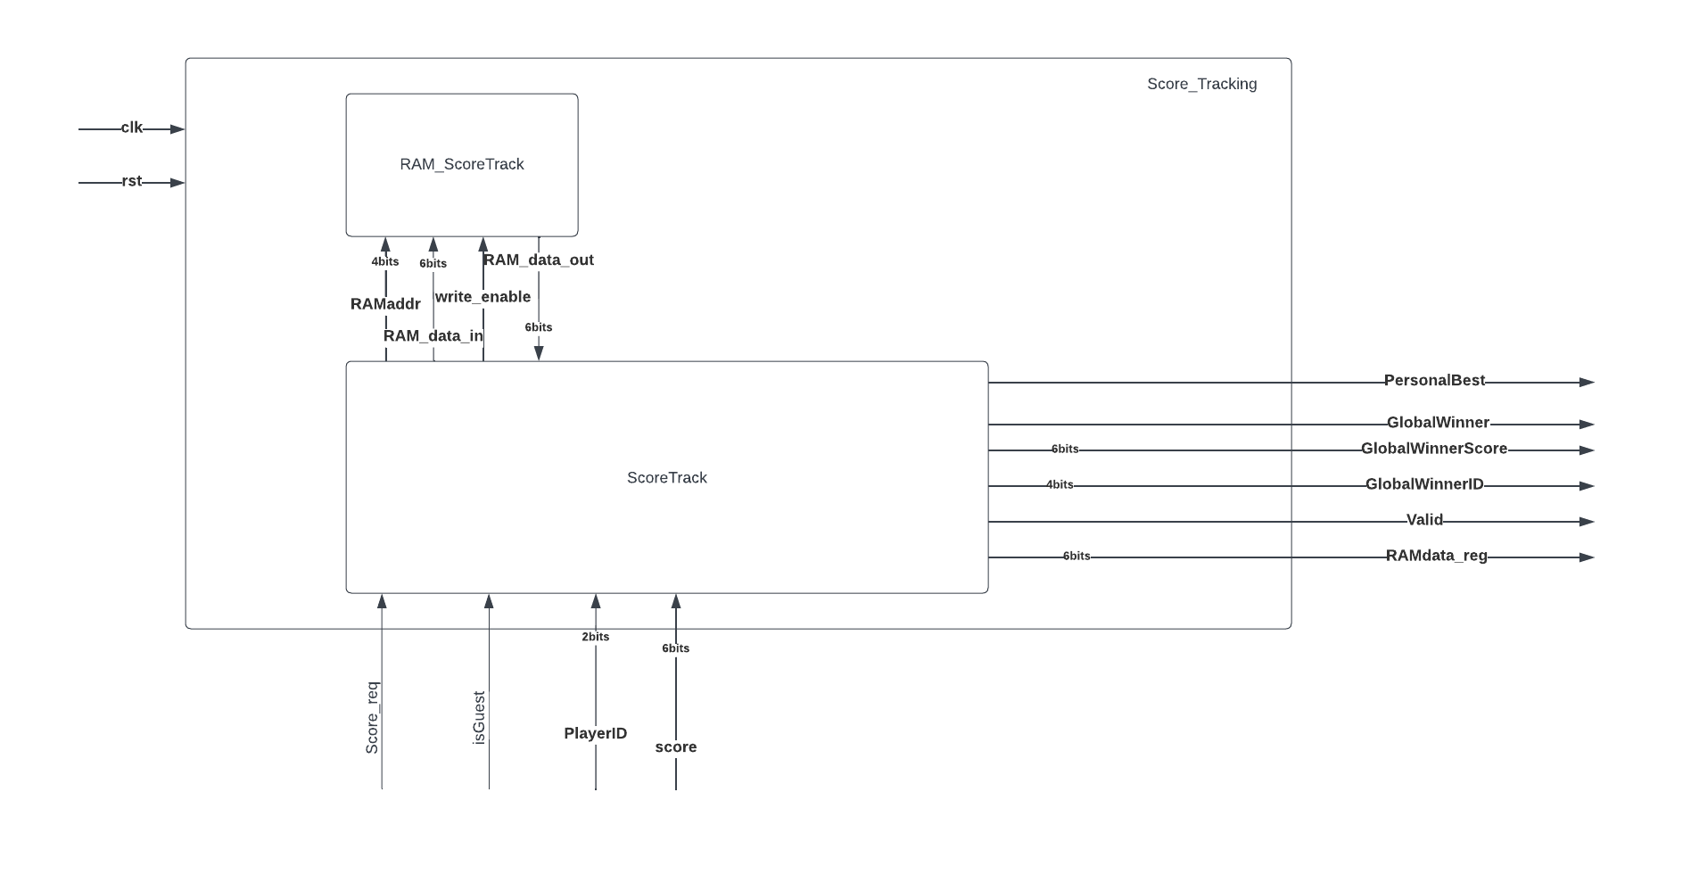

* This module has two daughter modules namely RAM_ScoreTrack module and Score Track module, which helps in tracking the personal best score, best score in the team.
* RAM_ScoreTrack stores the scores of the players with a 7-bit data buses (RAM_data_out and RAM_data_in) and address bus of 5 bit (RAMaddr). The write_enable signal goes high whenever data is being written to RAM.
* This module gives out the GlobalWinnerScore(6bits), PersonalBestScore(RAMdata_reg-6bits) to the multiplexers through a BinarytoBCD converter module so that they can be displayed onn seven segment displays. GlobalWinnerID(4bits), is directly given as an input to mux to be displayed.
* PersonalBest, GlobalWinner, and valid are sent to the game controller module as signals to indicate if the player has achieved their personal best or the highest score among all the player i.e., global winner. The valid bit is sent as a check-signal to the game controller which helps the game controller in determining if it is a valid data from score track module.
* It receives score(6bits), score_req from the game_controller module.
* The isGuest, PlayerID(2bits) come from the Access Controller module indicating if the player is a guest (isGuest going high) and the Internal Player ID from the Access Controller.
* Clk and rst and clock and reset signals.

**15.Game controller:**

* This is the heart and brain of the game. It has two internal modules-
* RAM_logout - state of the players is stored when they log out of the system which helps to resume back at the same level where they log out previously) and game_controller (controls the game flow.
* The data buses of the RAM are of 14 bits wide (RAM_data_in and RAM_data_out) and the 14 bits are segregated as follows:
* [13:10] bits store the Level value.
* [9:7] LED_reg value which is an internal register of the game controller. This helps in controlling the LEDs on the board.
* [6:0] score of the player.
* Game controller gives the signals Timer_enable, Timer_reconfig, Ones_digit(4bits), Tens_digit(4digits) as inputs to and receives time_out as input from reconfigurable timer module.
* It has all the button inputs (multipurpose button, player load button, game_start button) connected through buttonshaper modules.
* Multipurpose button to switch from player input value display to random numbers display during the gameplay state and for the players and GlobalWinnerID, GlobalWinnerScore, PersonalScore display during the game over state.
* Player load button for loading the player inputted BCD numbers into corresponding load registers (PLO, PLT) during Gameplay state. The player load button is also used for logging out of the game during WAIT_FOR_GAMESTART state.
* The game_start button is used for starting the game and to restart the game for the next math puzzle.
* 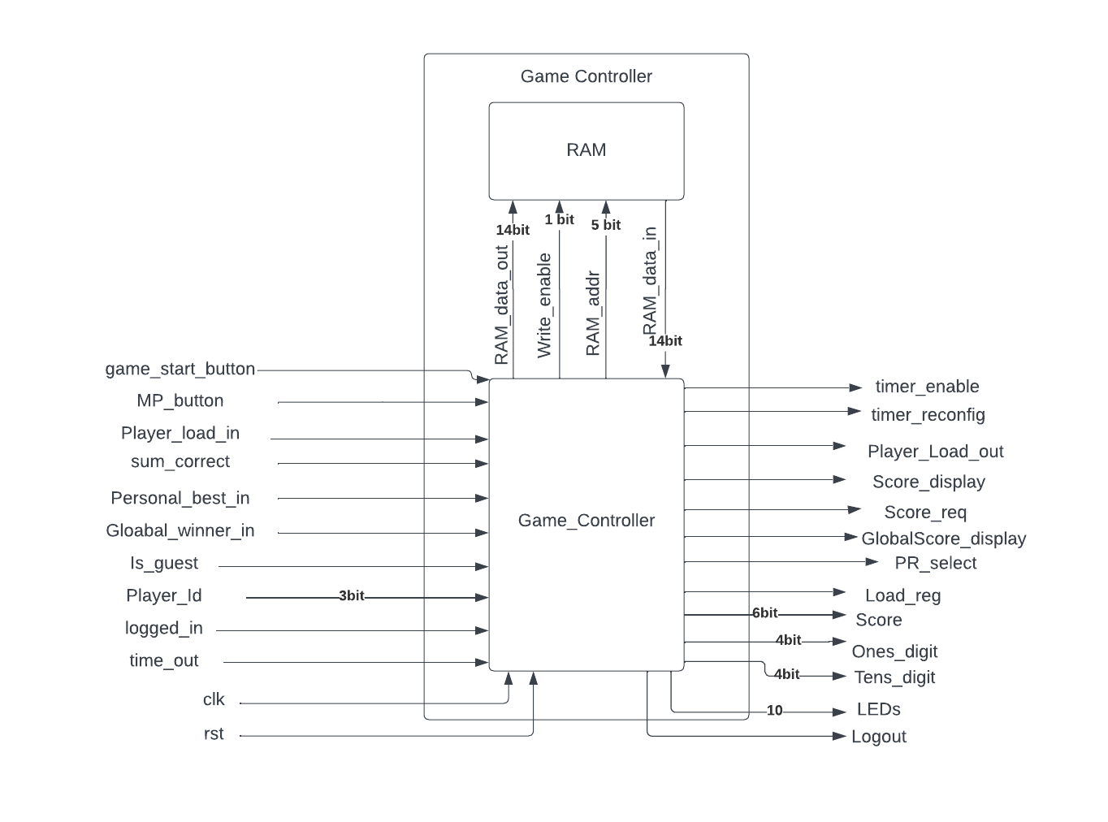score (7 bits) is the score of the player calculated inside the game controller and sent out to the score tracking module and to binary to BCD converter to be displayed on the seven segment displays.
* Score_req is sent to the Score tracking feature and goes high when MP_button signal goes high in WAIT_FOR_GAMESTART state or gameover state.
* LEDs are a 10-bit output used to control the LEDs on the board and depend on the value of internal LED_reg register.
* Logout signal is given to the AccessController module when the player presses player_load button.
* sum_correct signal indicates if the player got the answer right and comes from the Verify module through a button shaper module.
* Clk and rst are clock and reset signals respectively.

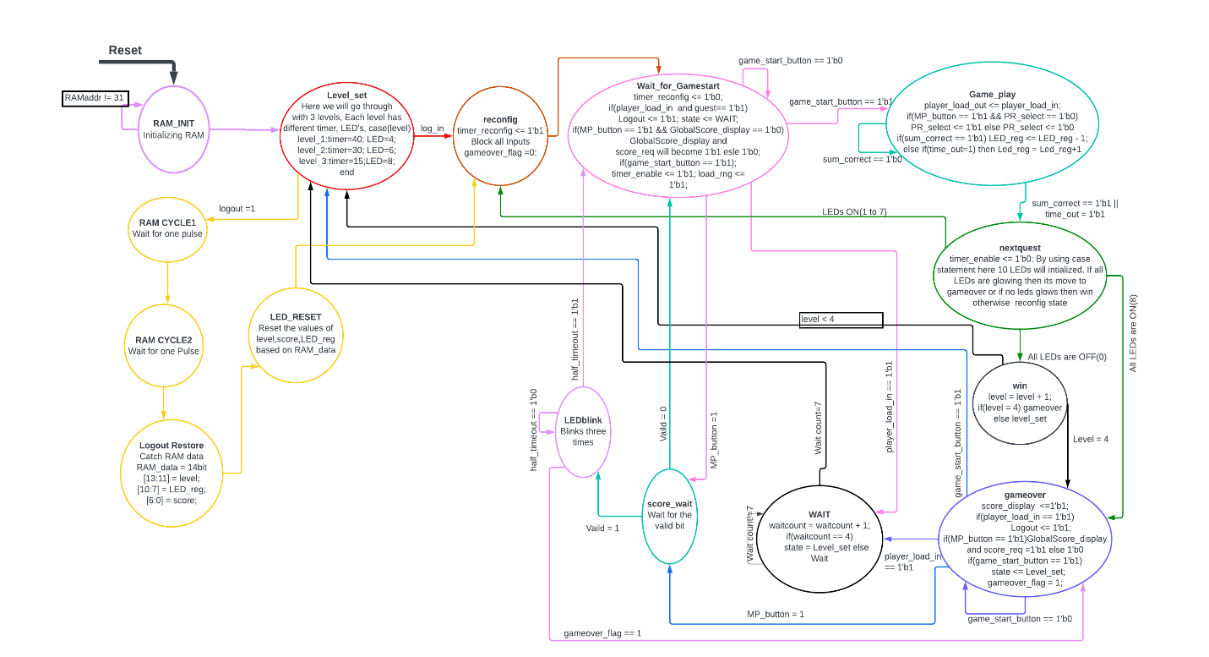**Game Controller FSM:**

* For a better view, visit:

<https://drive.google.com/file/d/1FPOZuTjwJMXAQO9rk6OLaNCFddpohJiM/view?usp=sharing>

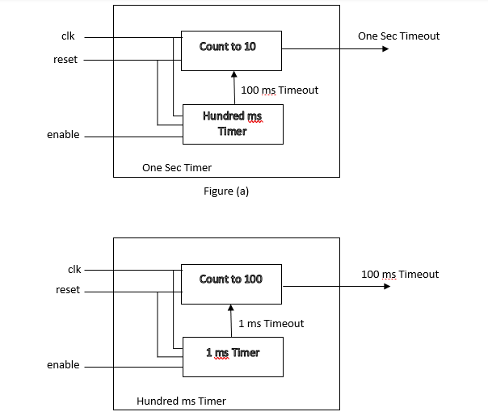**Timer Module:**

* The Nested One-Second timer consists of 5 modules with One Sec Timer being the top module and the rest are nested.
* The FPGA has a clock signal of 50 Hz which is given as inputs to the modules.
* The reset signal resets the timers and they start counting from the beginning.
* The enable signal is a long high signal which initiates the timer and the timer starts counting the clock pulses as long as enable is high.
* There is a ‘1 ms Timer’ module in the bottom that counts 50,000 clock cycles which accounts to 1ms and sends out a 1msTimeout pulse signal to the module on top of it.
* The ‘count to 100’ module takes the 1msTimeout as input and counts the number of 1msTimeout pulses. When the count reaches 100, it sends out the 100msTimeout signal, which as the name suggests accounts to 100ms.
* The ‘count to 10’ module takes the 100msTimeout as input and counts the number of 100msTimeout pulses. When the count reaches 10, it sends out the OneSecTimeout signal, which as the name suggests accounts to 1 second.
* **LFSR Based One millisecond Timer:**
* The One millisecond timer in this module is a 4-bit Linear Feedback Shift Register based timer.
* 4 shift register are cascaded with ‘one to many’ feedback connections via xnor gates.

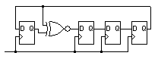

* The terminal value of the LFSR counter is found by running it parallel with the regular one ms timer and checking the corresponding value of LFSR timer at 50000 clock cycles.
* **Half_sec_timer:**
* This module is similar to the One second timer but the Count to 10 module is replaced by a Count to 5 module essentially making it count Half second.

**16.Digit Timer:**

seven_seg_display

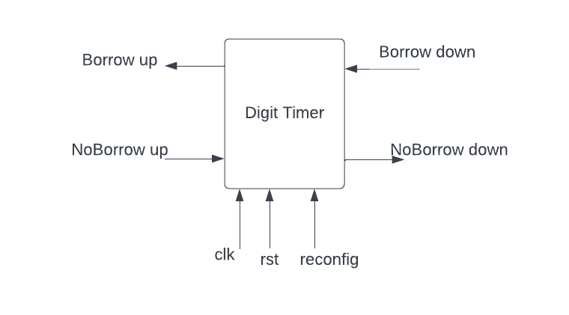

4

Reconfig_value

* The digit timer module is used to display the timer count on seven segment displays.
* It is initially set to value 9 and when the Borrow down pulse is high, it decrements by 1 value.
* As soon as it reaches ‘1’ it checks if the NoBorrow up signal is high.
* If the NoBorrow signal is low, it means that the adjacent module is not ‘0’ and it can give borrow to this. So, the Borrow up signal goes high and the digit timer value resets to 9 after 0.
* If the NoBorrow up signal is high, it means that the adjacent module has reached to ‘0’ and it cant take borrow from it. In this case the NoBorrow signal goes high.
* The reconfig signal reconfigures the digit timer value to the value sent through the Reconfig_value bus(4 bit wide).
* The reconfig signal reconfigures the digit timer value to the value sent through the Reconfig_value bus(4 bit wide).

**17.Two-digit Timer:**

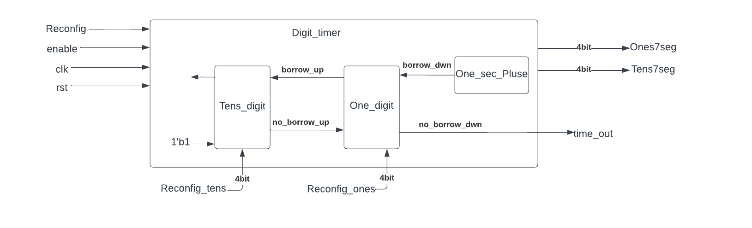

* The Two-digit Timer module consists of 2 digit timer modules connected inside to represent one’s and ten’s digit of the timer.
* When the enable signal is high, the 1 sec timer sends out pulses for every second(One_sec_pulse) which act as input to the Ones digit timer module and the count starts to go down from 99.
* As soon as the count reaches 00, the time_out signal is sent to the Game Controller to stop the timer which in turn turns the enable signal to low.
* The reconfig signal is given to each of the digit timer.
* Reconfig_ones and Reconfig_tens come from Game Controller module and indicate the value to which each of the 2 digit timers reconfigures based on the level of the game.
* The Ones_decoder_in and Tens_decoder_in are inputs to decoders to display the timer value.
* clk and rst are clock and reset signals.

**18.LEDBlink Module:**

* The LEDBlink module helps indicate the Global Winner or Personal Best by blinking the LED lights for 3 seconds celebrating the win.
* The timer signal comes from the Half_sec_timer module which is a high pulse for every half second.
* The outputbits bus turns high and low for each of the 6 pulses of timer signal and are connected to the LEDs on the board through a 10 bit mux.
* Clk, rst and clock and reset signals respectively.

**1.3 Simulation Results**

**Score_Tracking:**

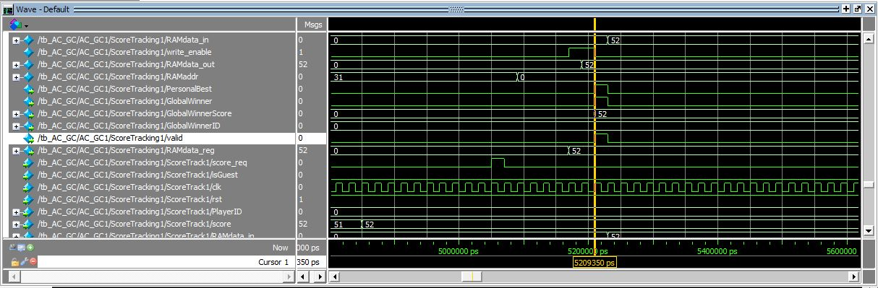

**Scoretrack:**

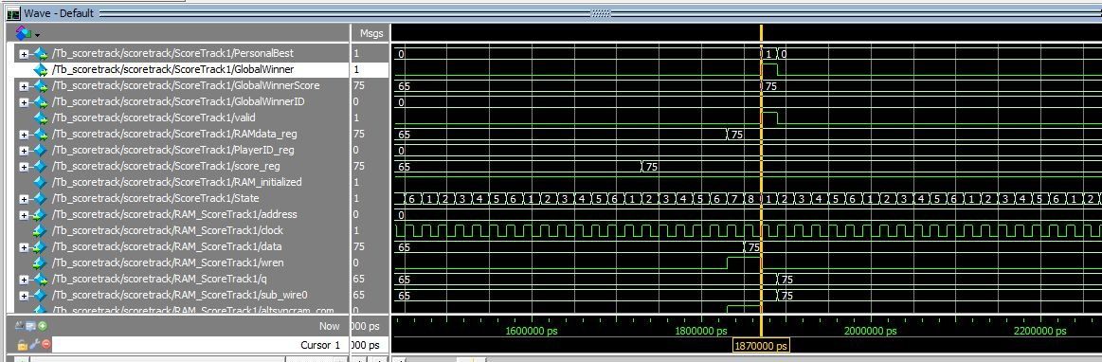

**Reconfig_Timer:**

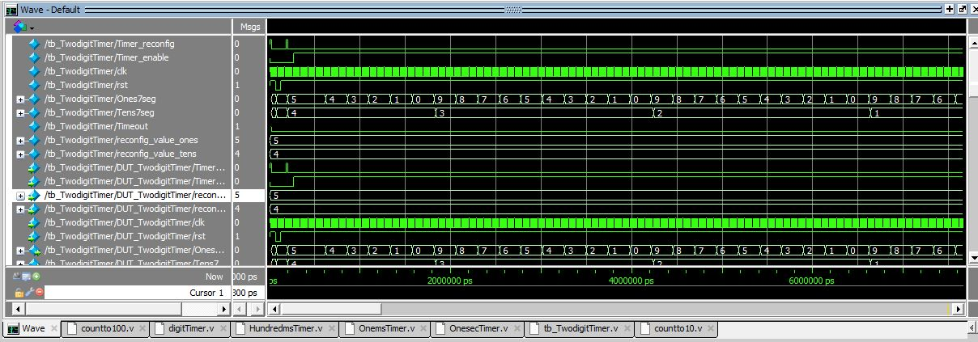

**Gamecontroller:**

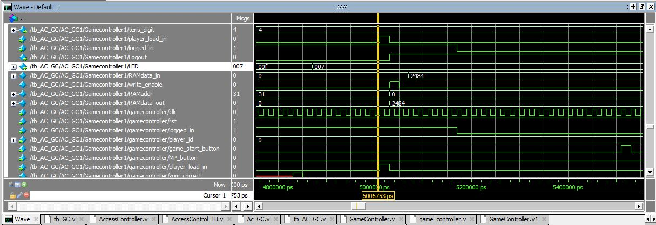

**LEDblink:**

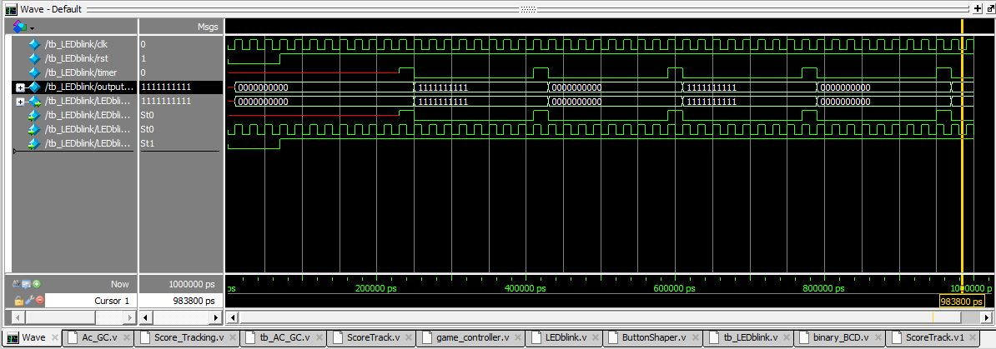

**1.4) Conclusion:**

We successfully completed the project with features like multiuser authentication, displaying global winner score, global winner id, personal best and also the score of the player when they lost or won the game. We wanted to implement some more features in the game like in between the levels, having display of pass or lost, at the start of the game, display of the game name.

**1.5) Appendix**

**Verilog Modules:**

1. **finalproject_TheLastOfUs:**

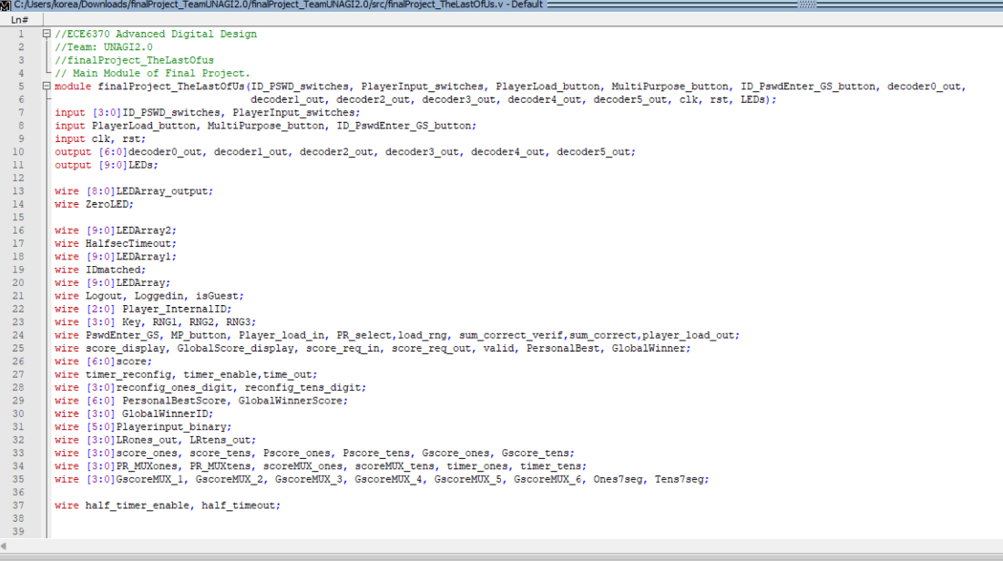

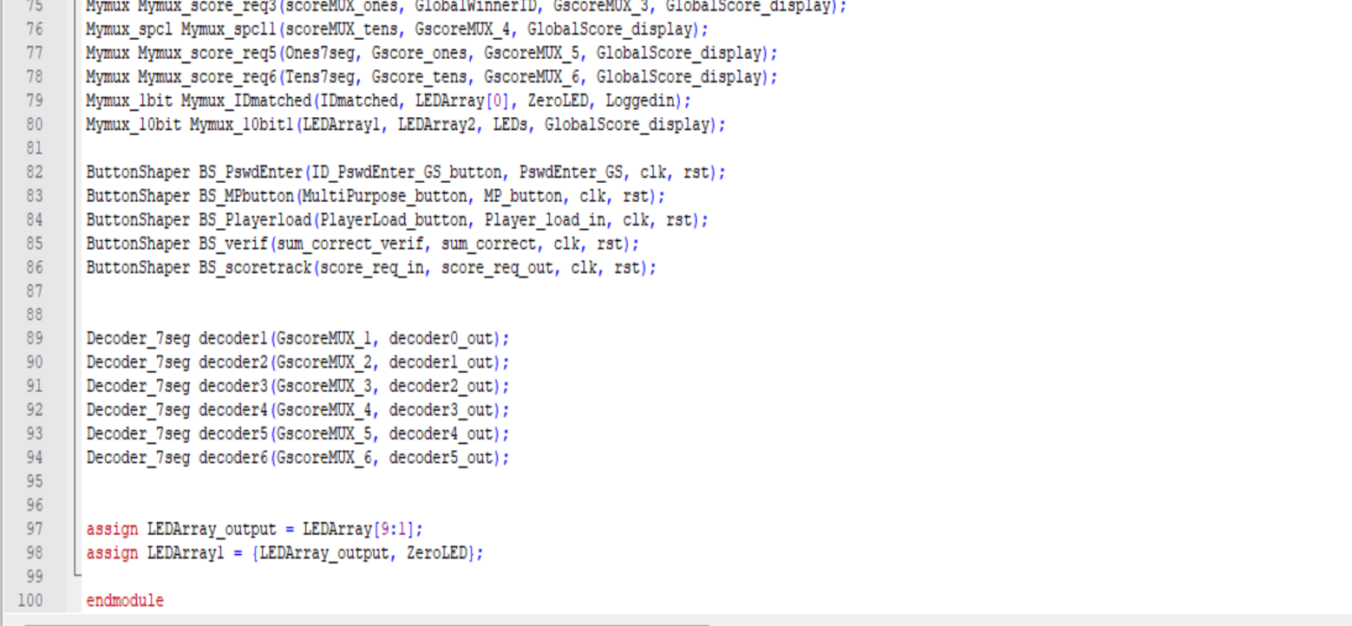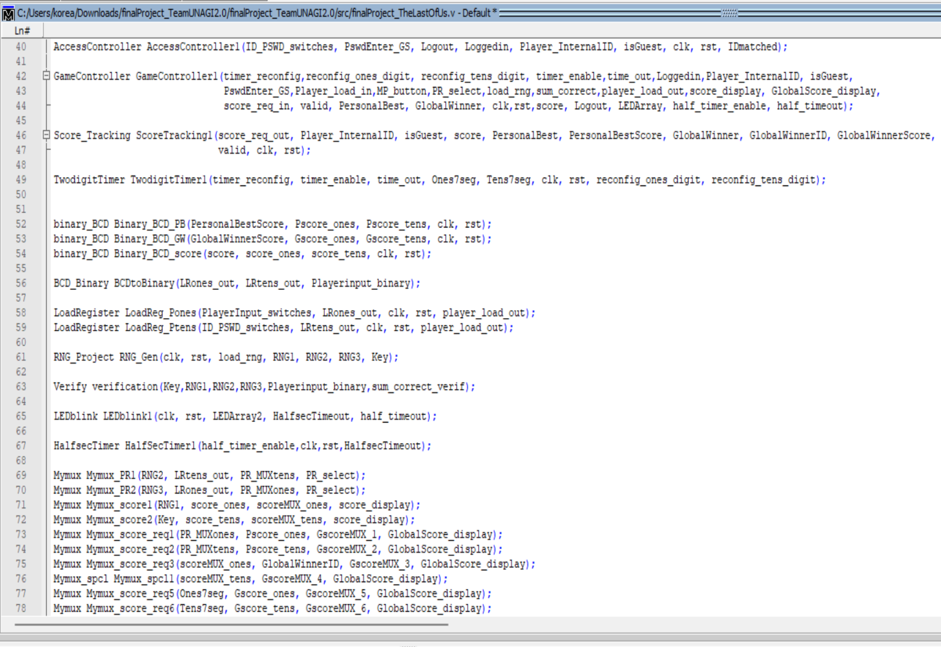

1. **Access Controller:**

**Main Module for Access Controller:**

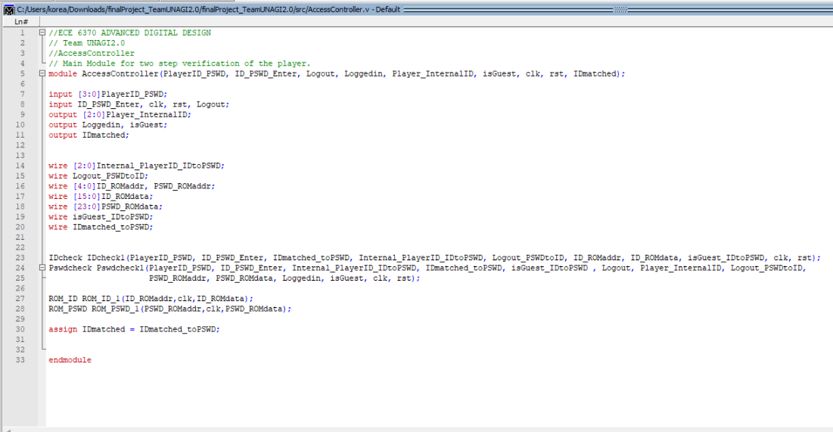

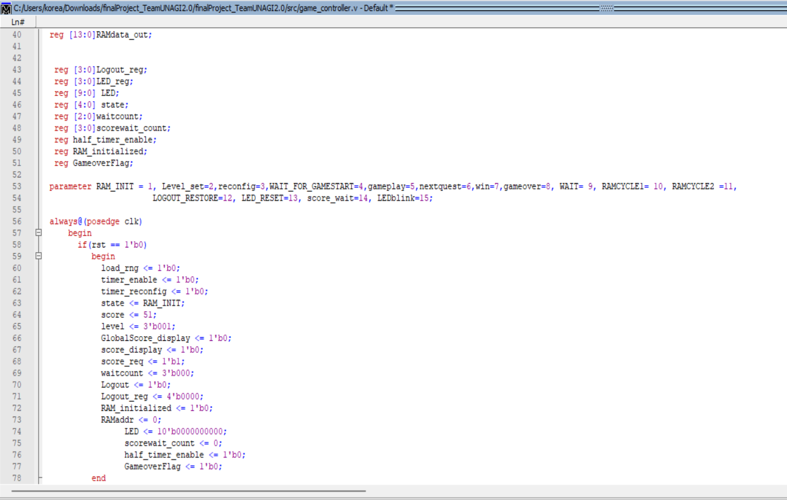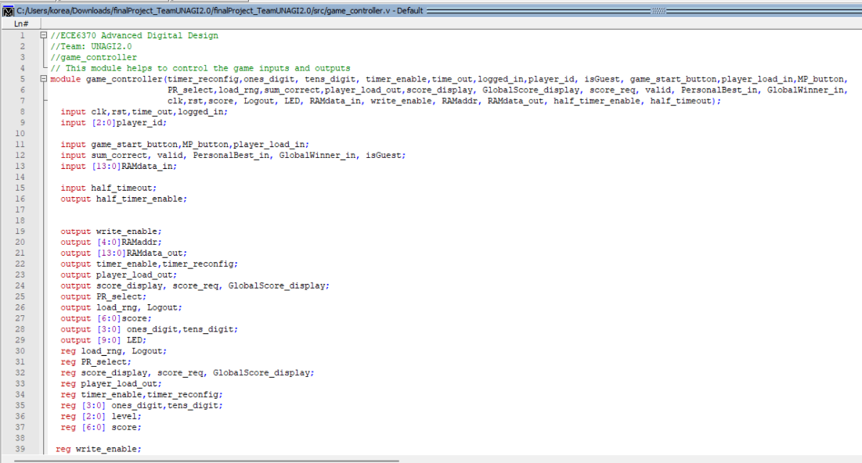**3.Game Controller:**

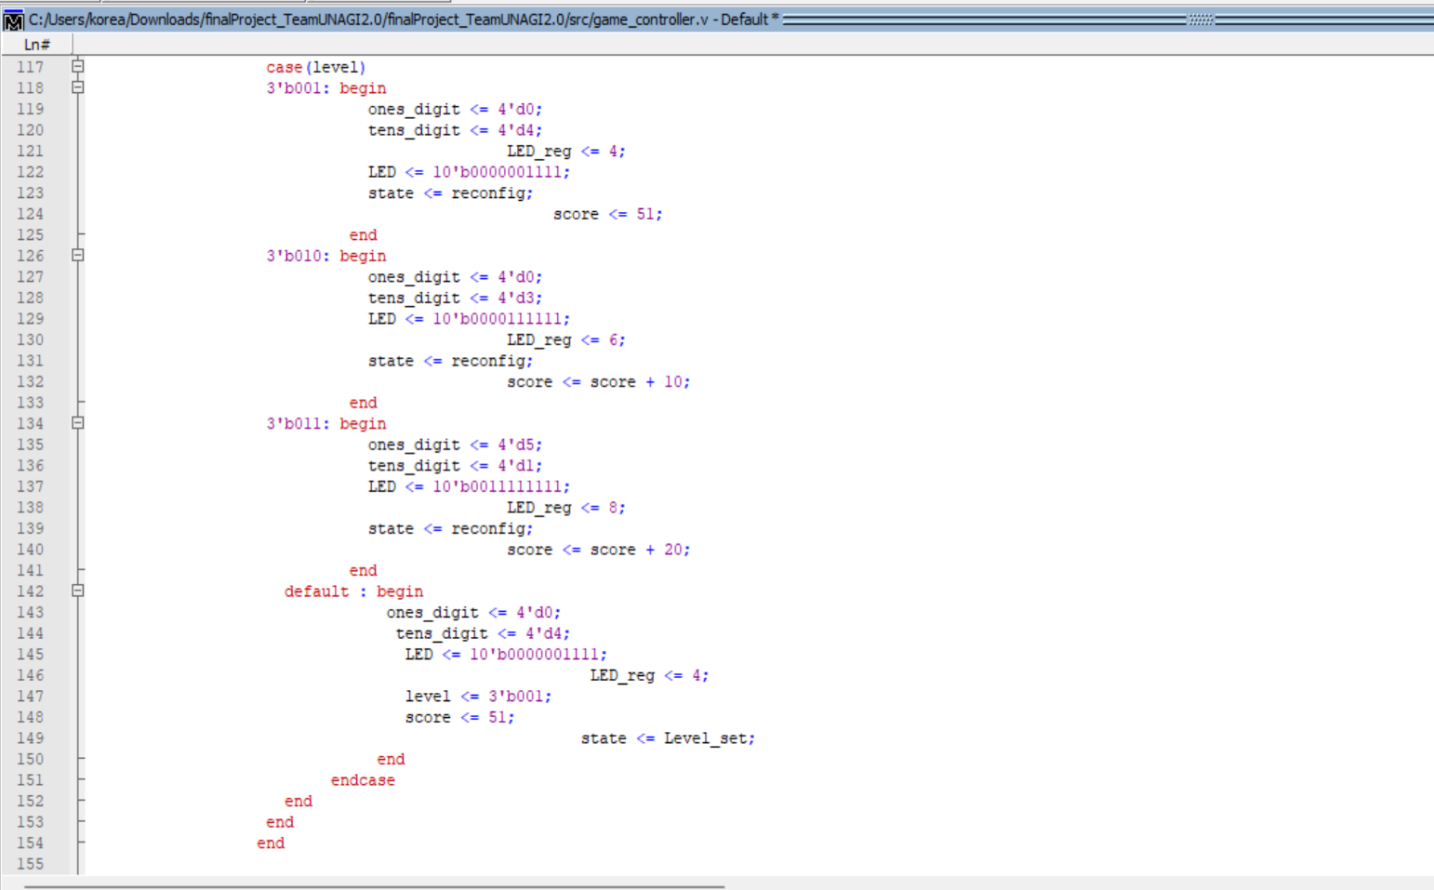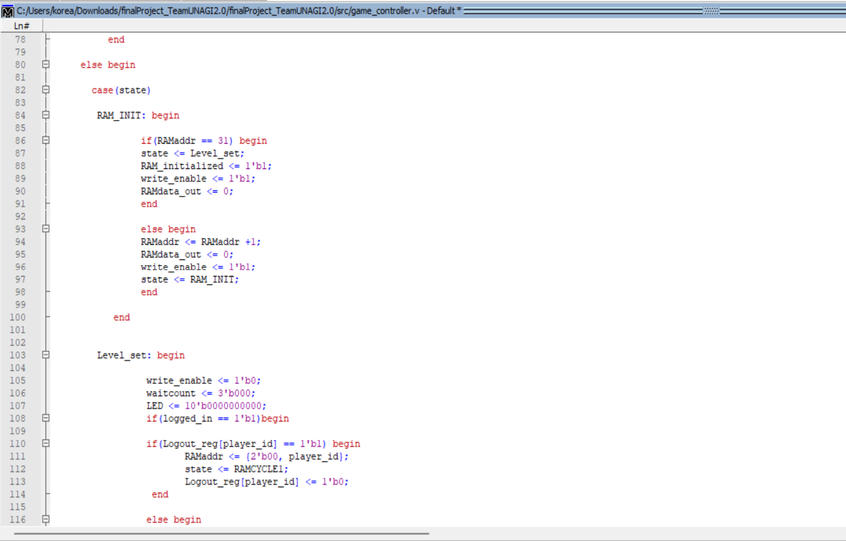

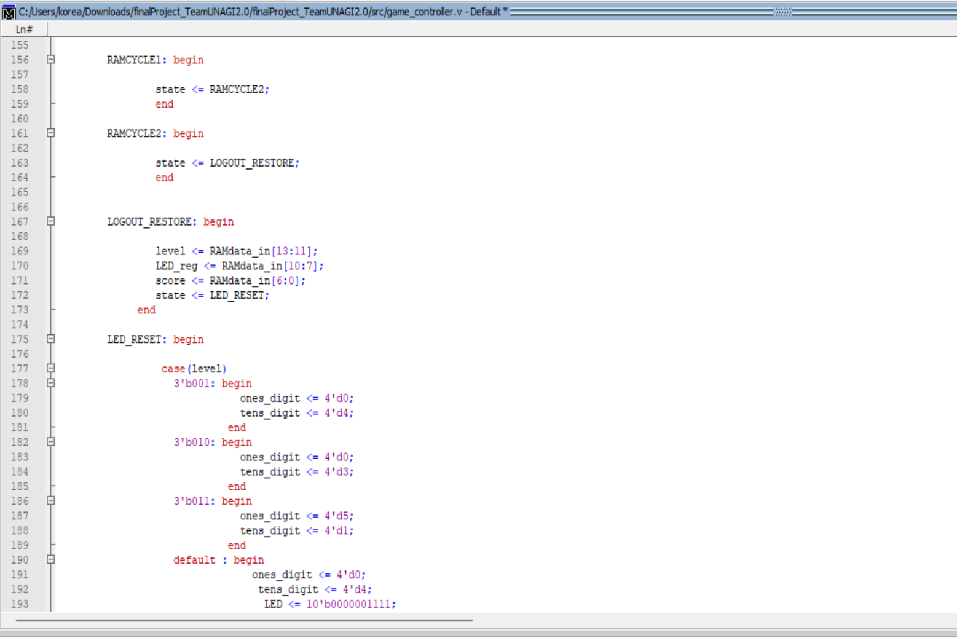

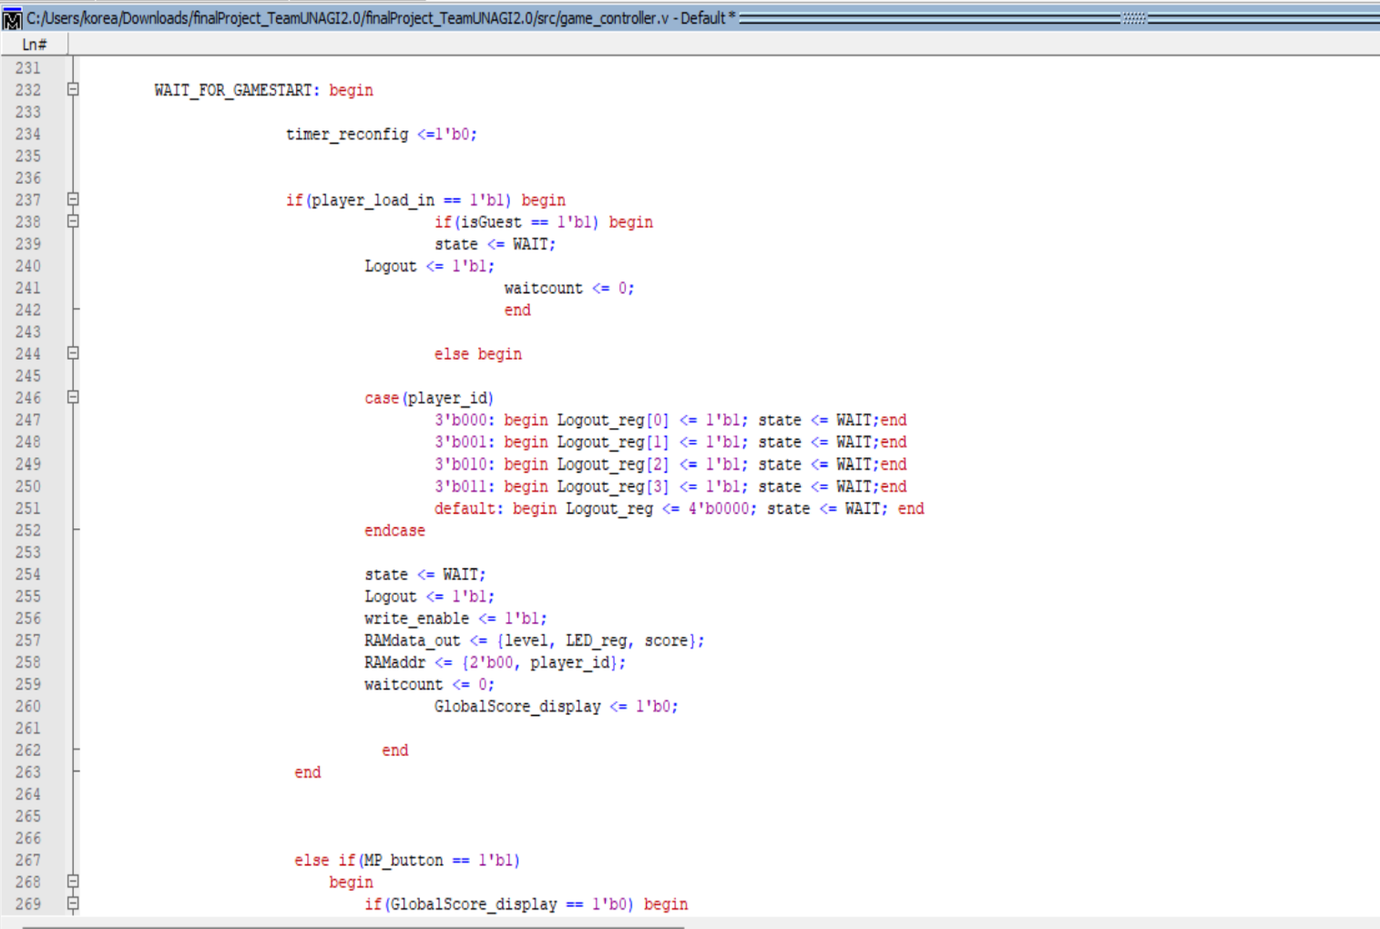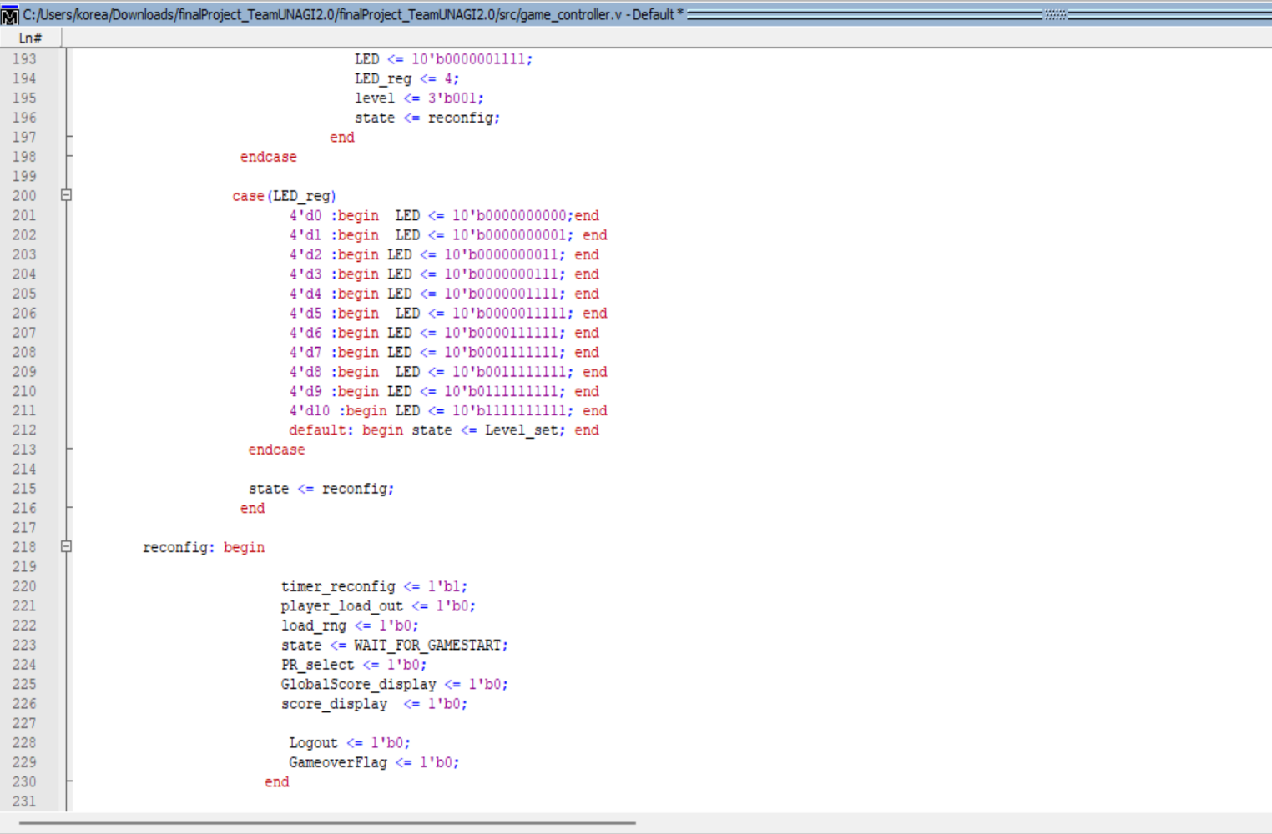

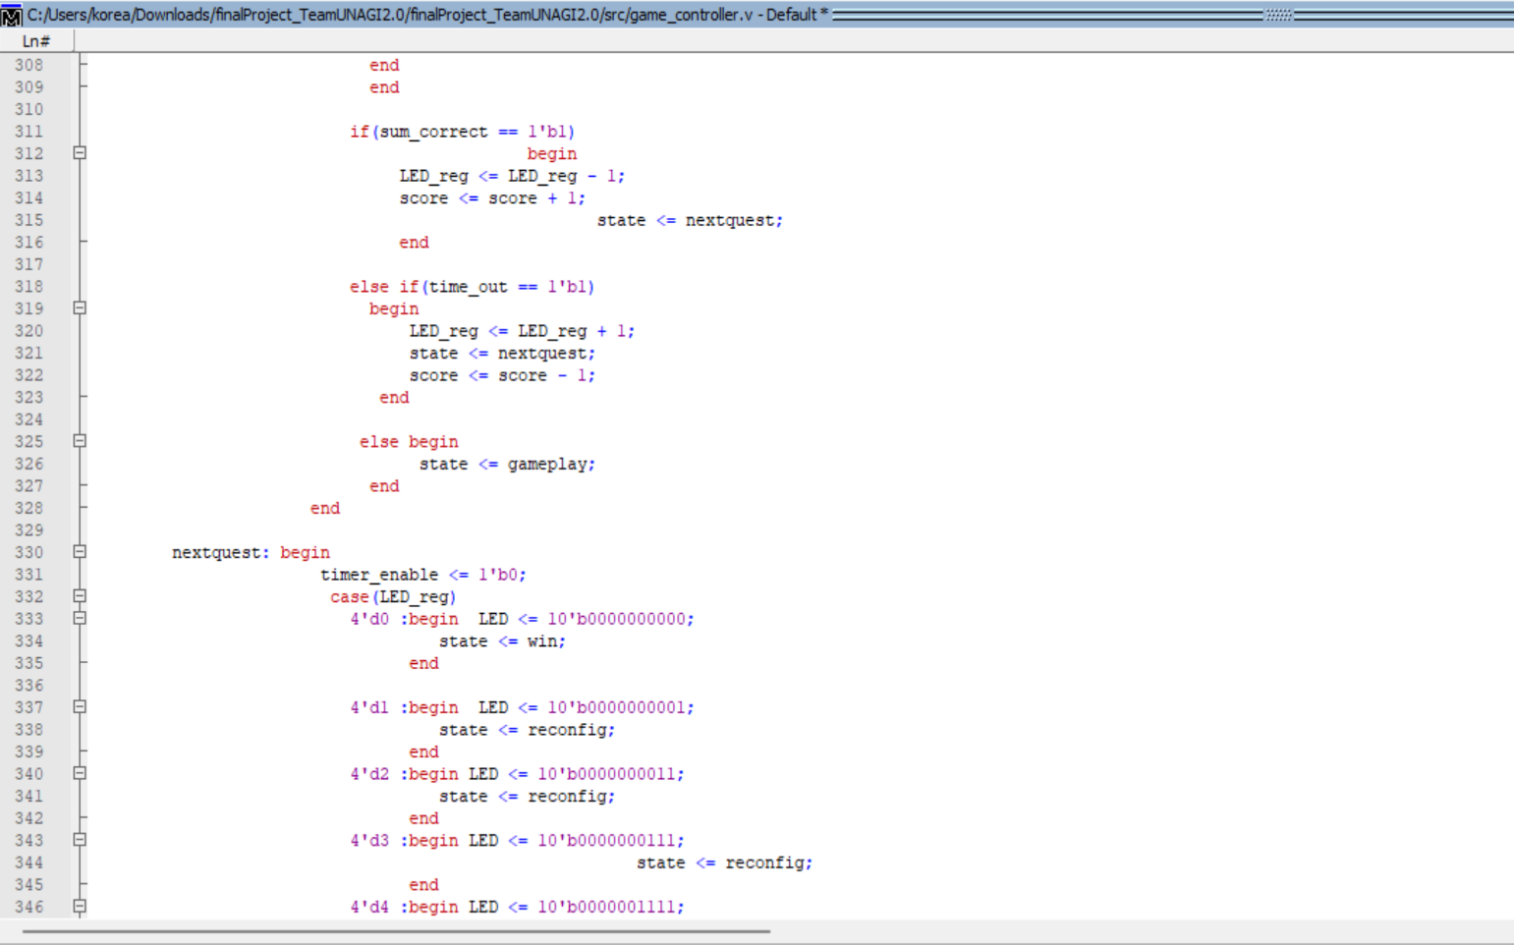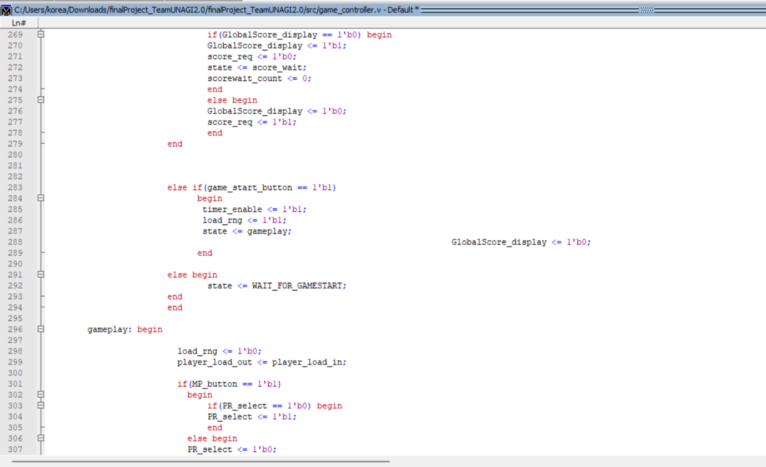

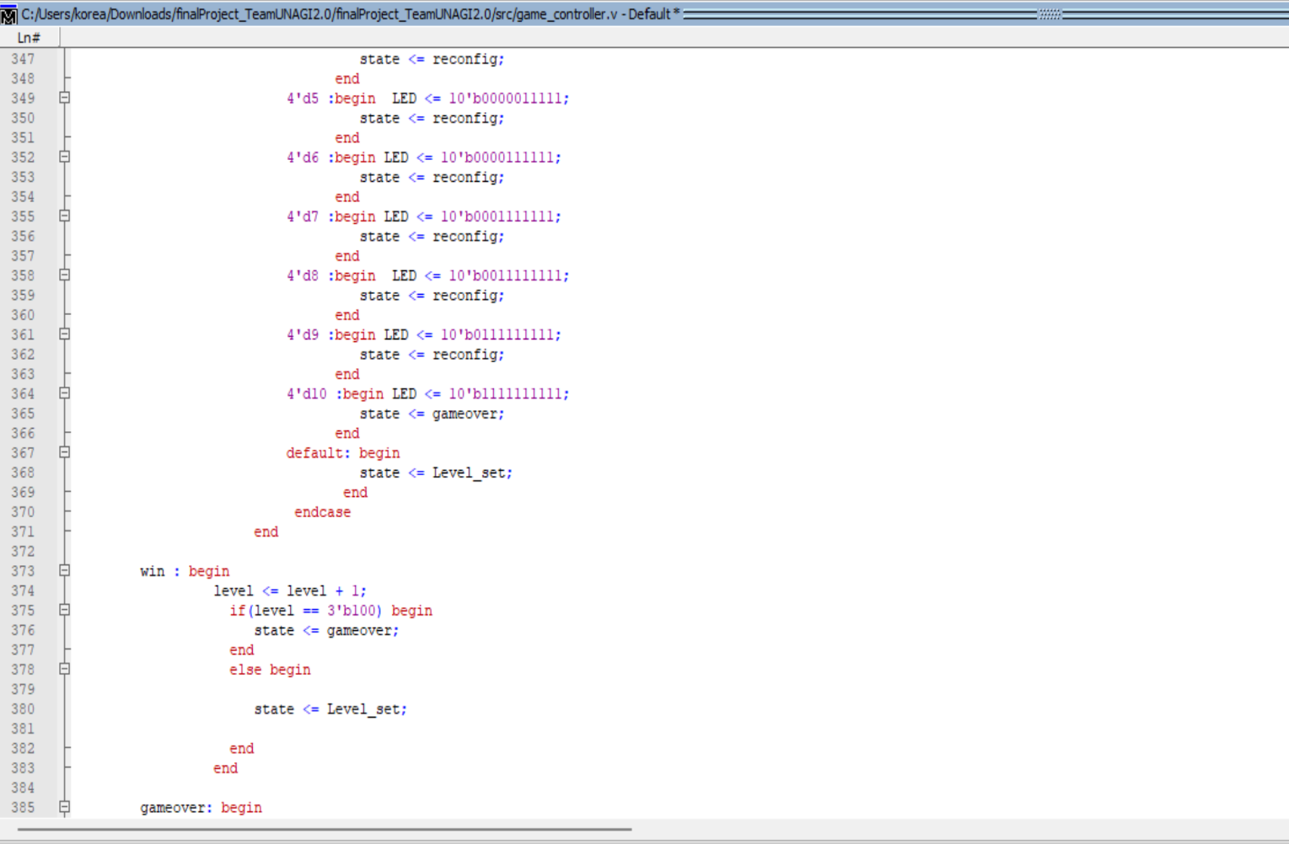

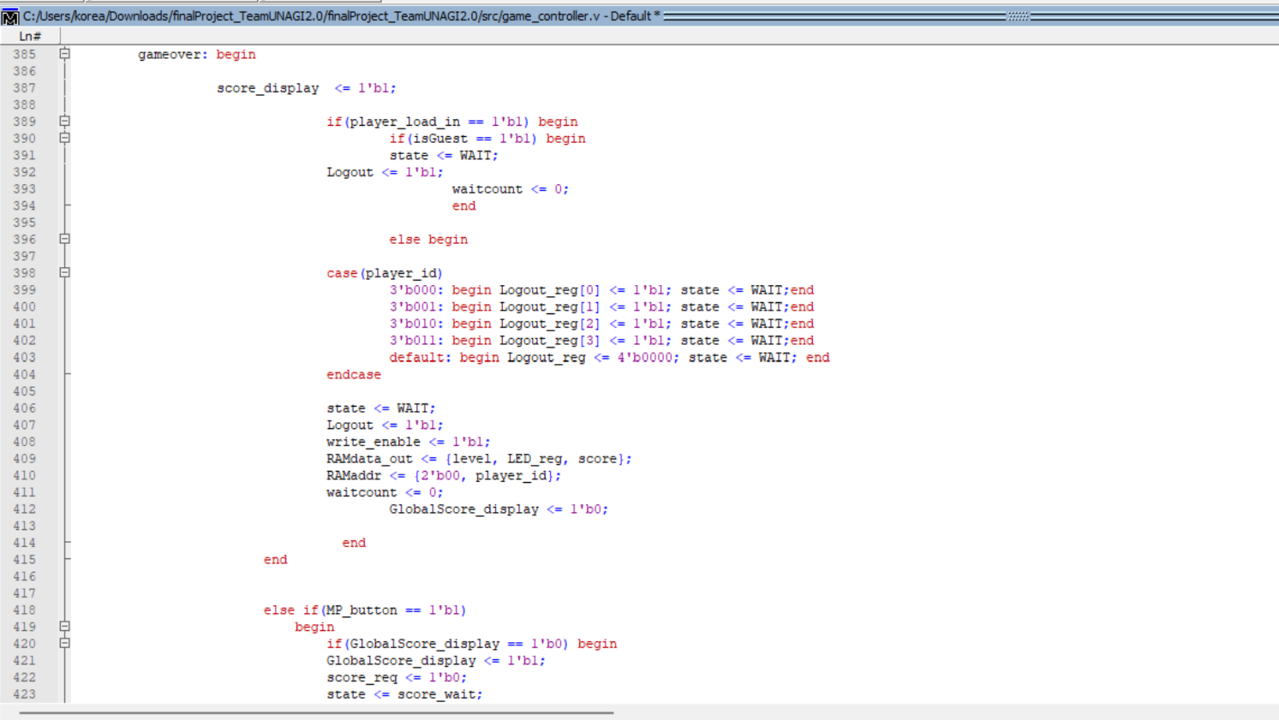

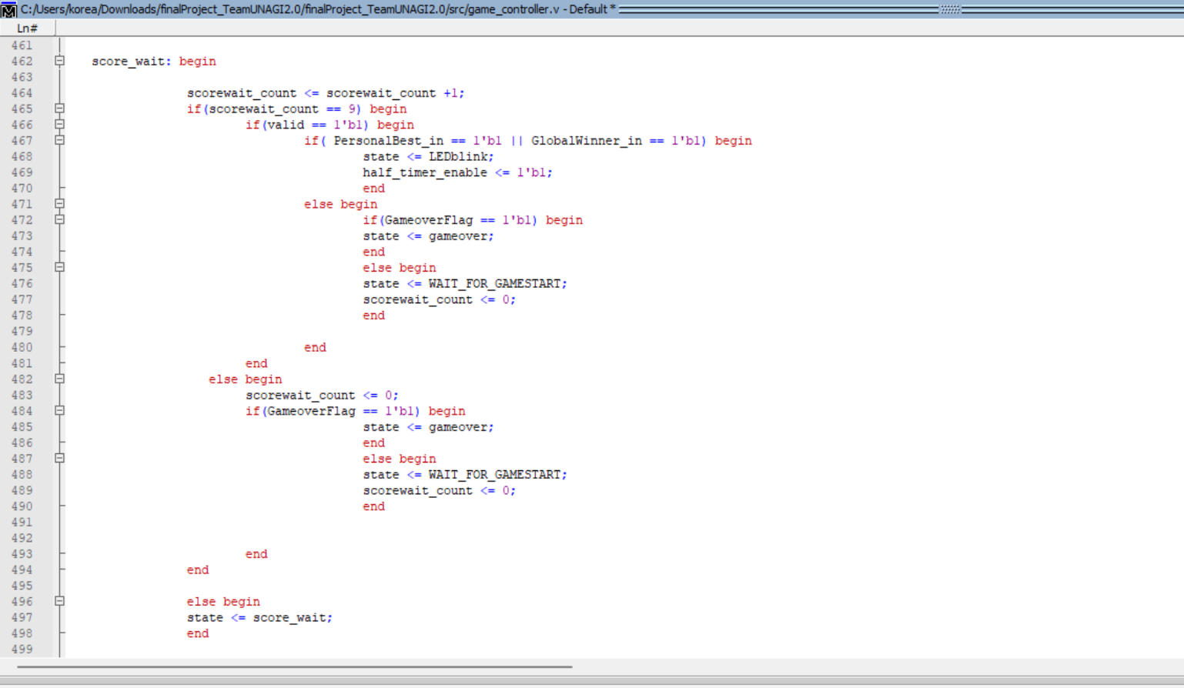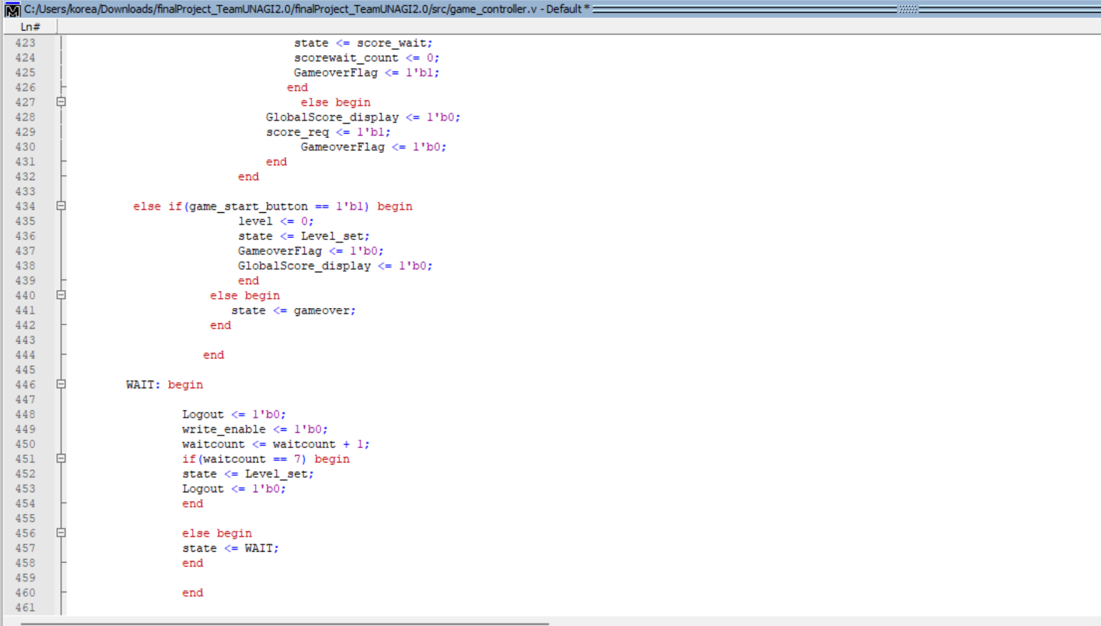

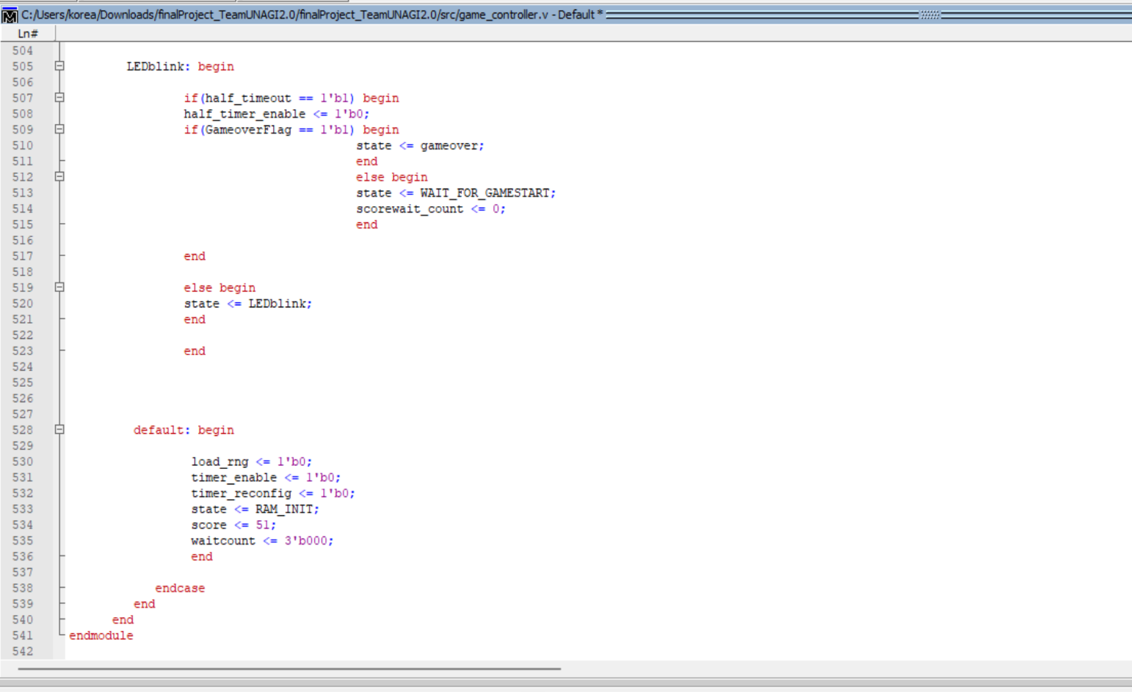

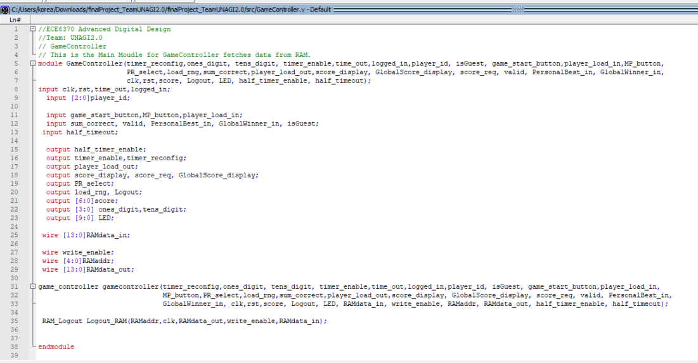**4.Game** **Controller**_**Top** **Module:**

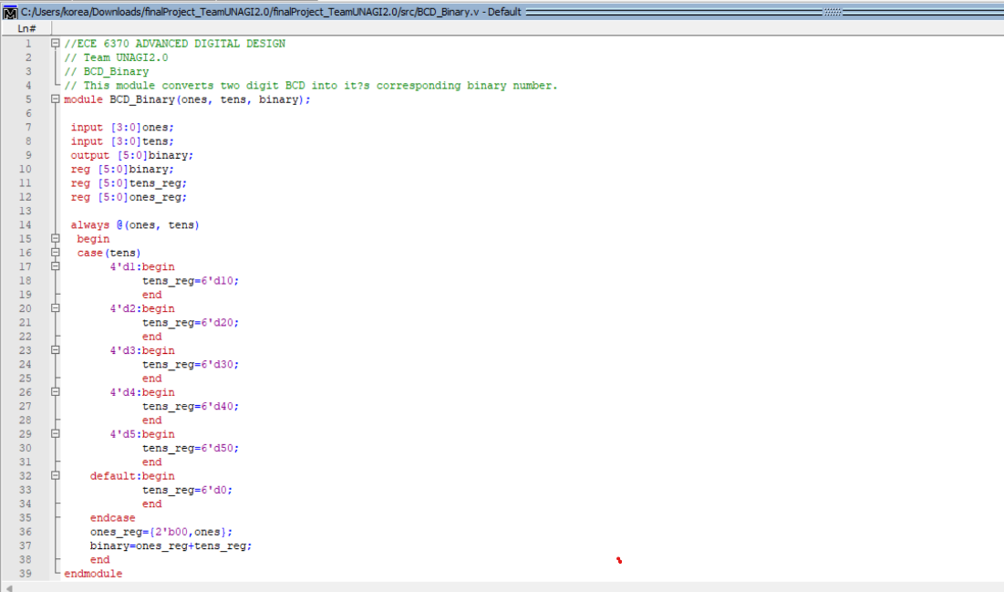**5.BCD to Binary Converter:**

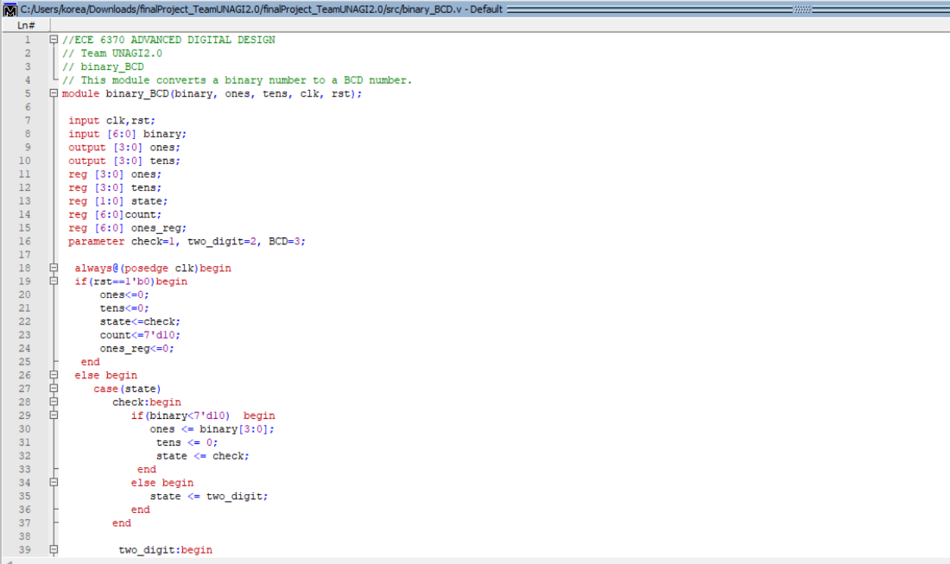**6.Binary** **to** **BCD** **Converter**:

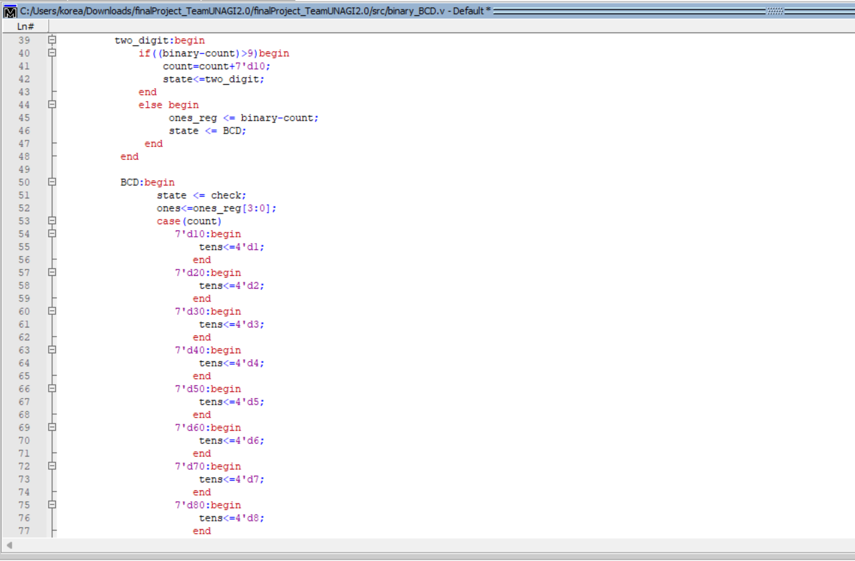

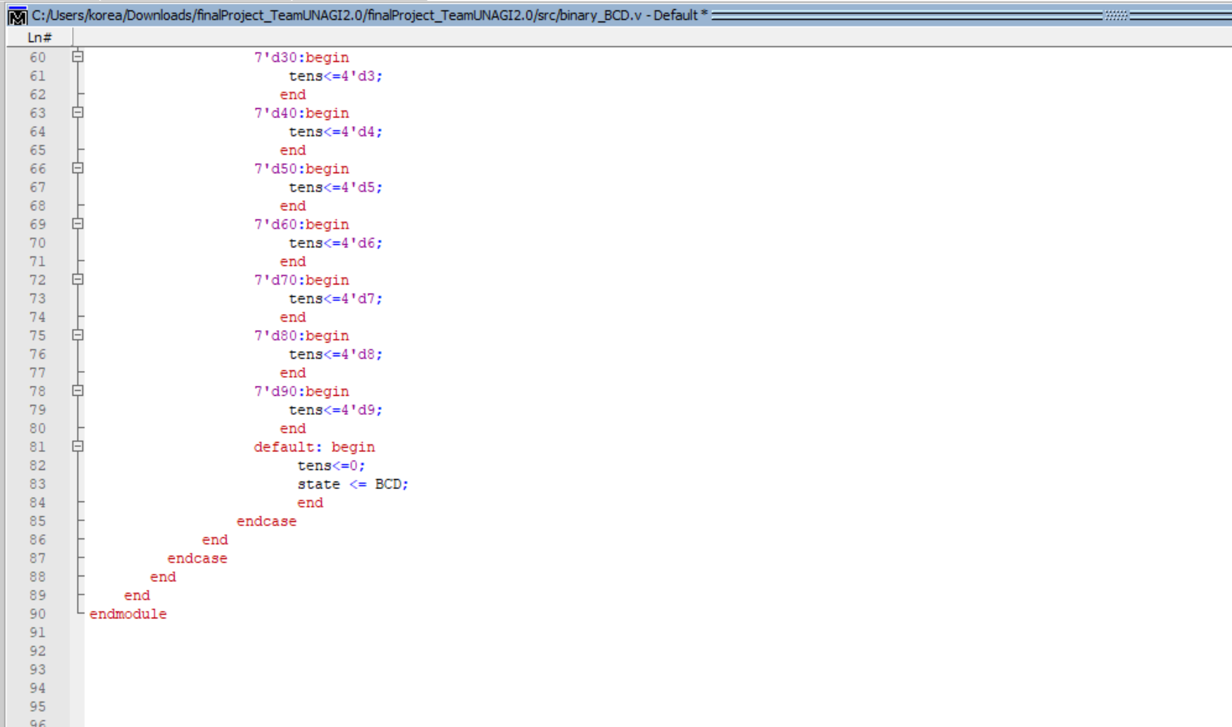

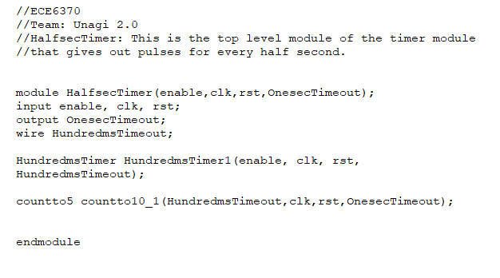**7.Half Sec Timer:**

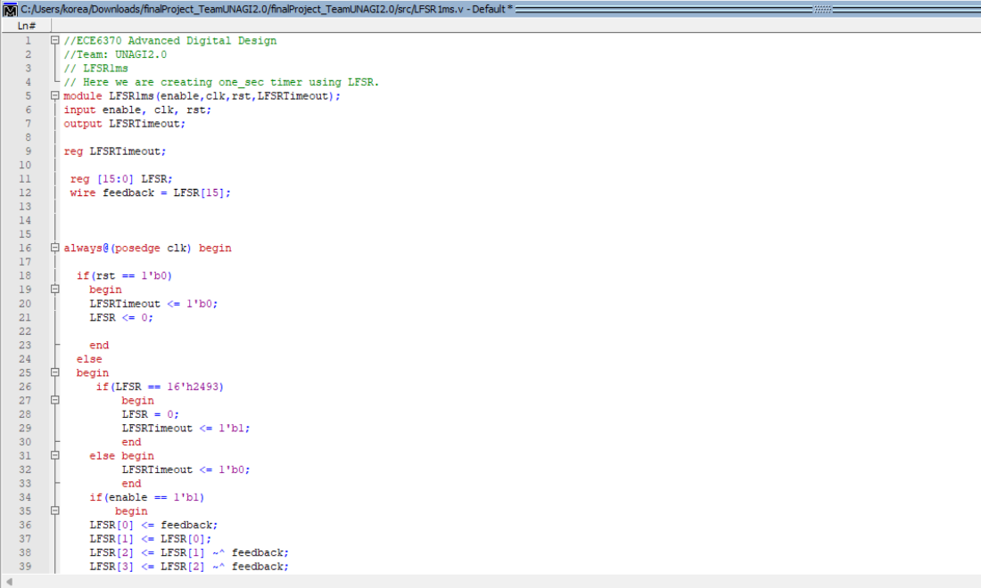**8.LFSR One_ms _timer:**

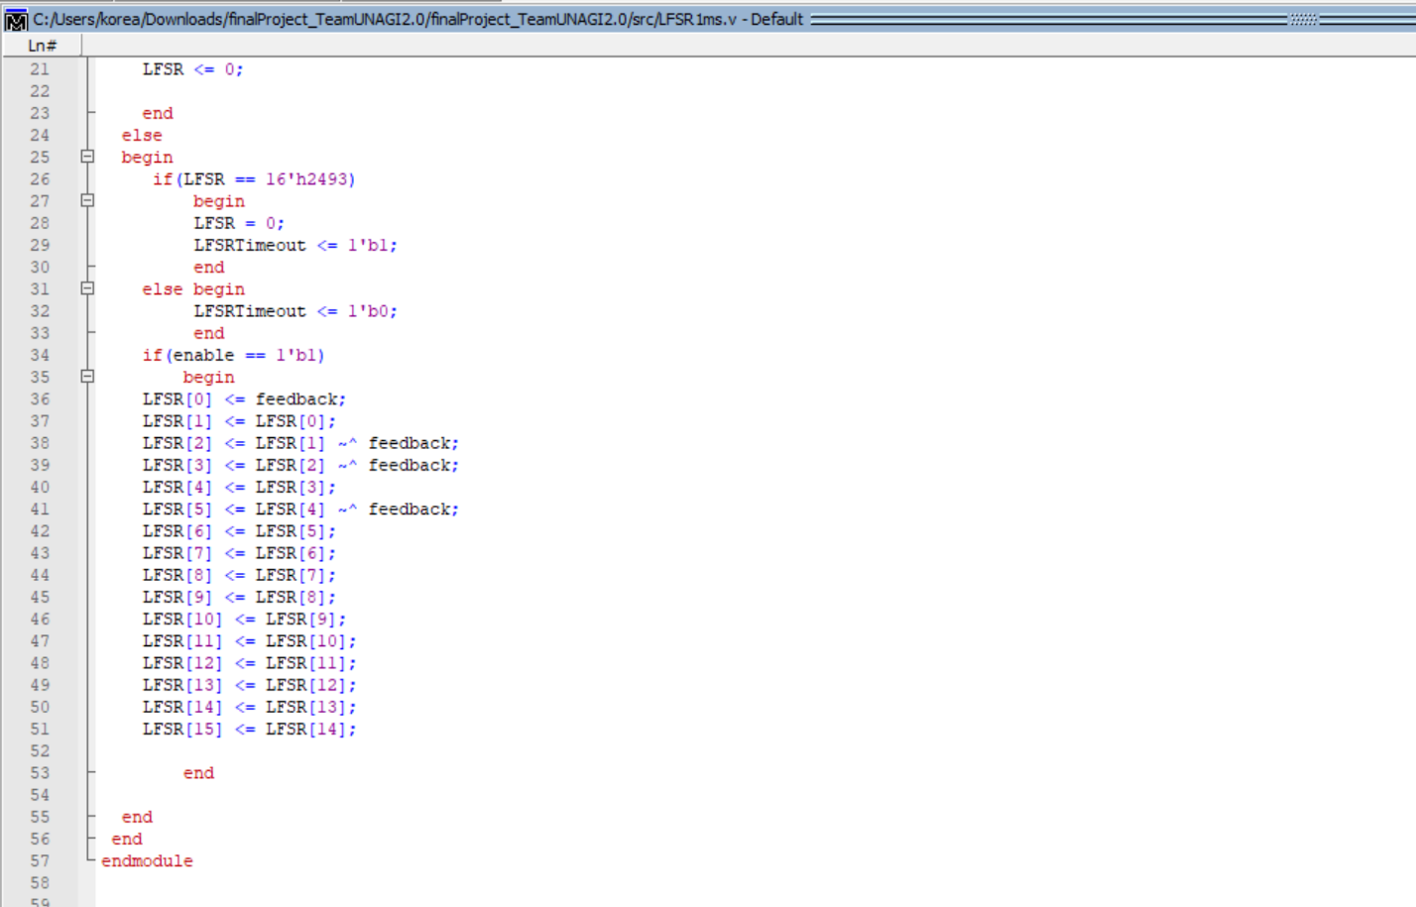**9.Button Shaper:**

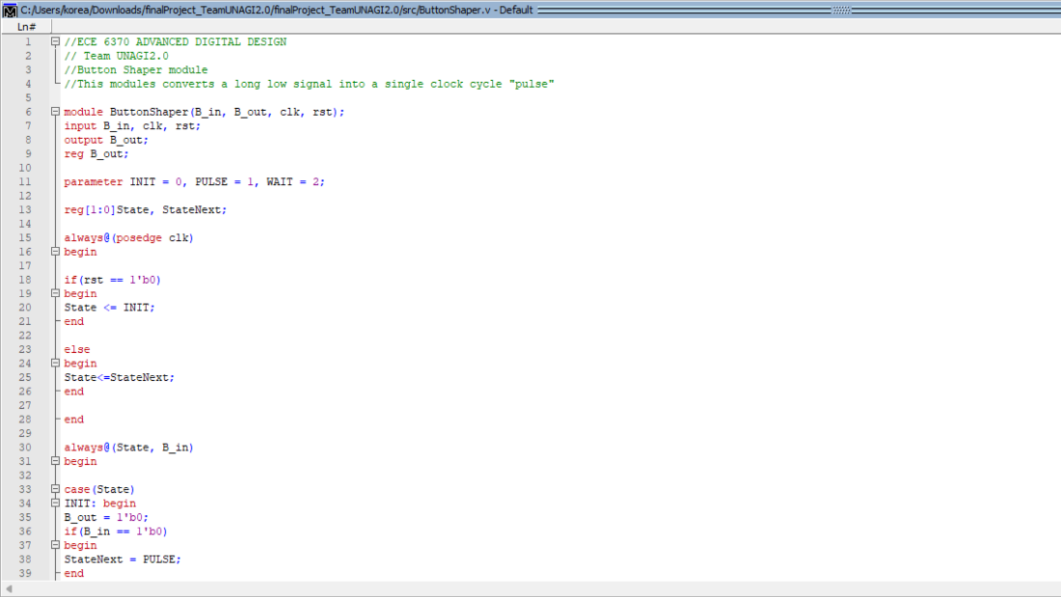

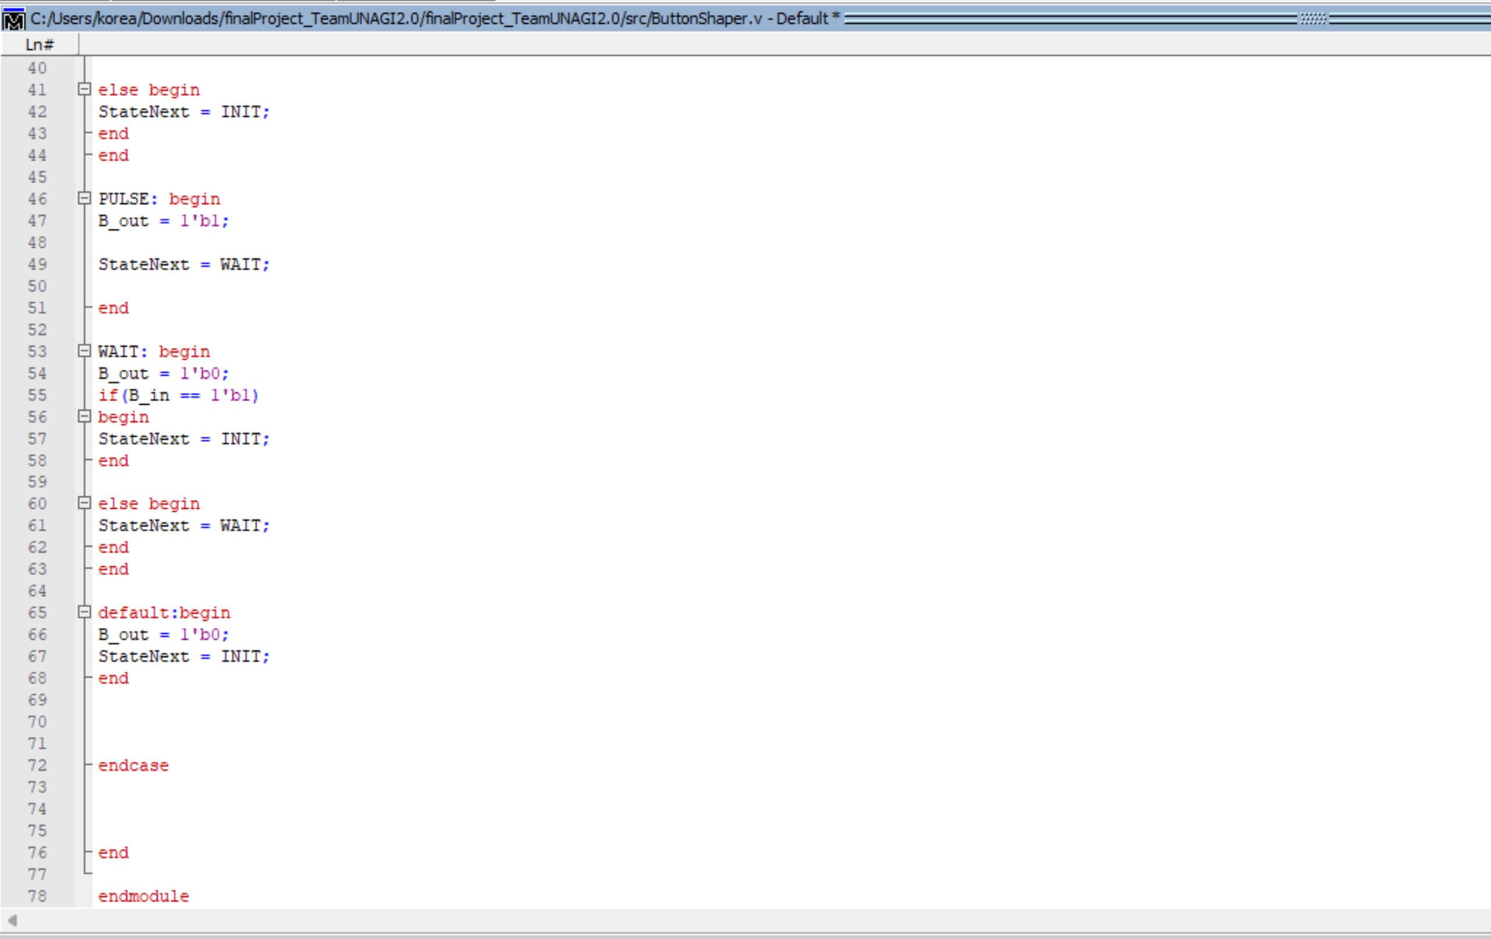

**10.Counter:**

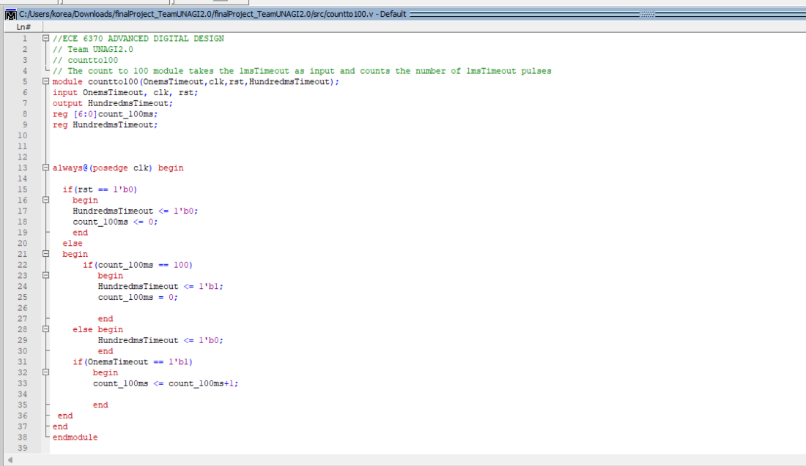

**11.Count to 10:**

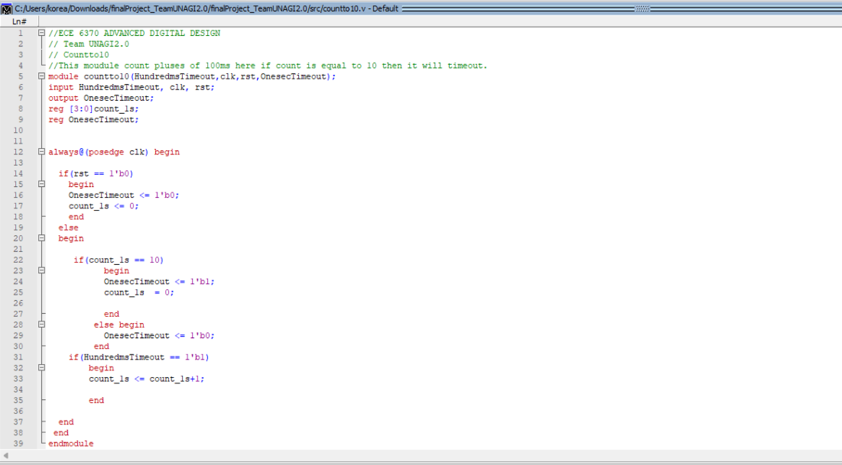

**12.Count to 5 :**

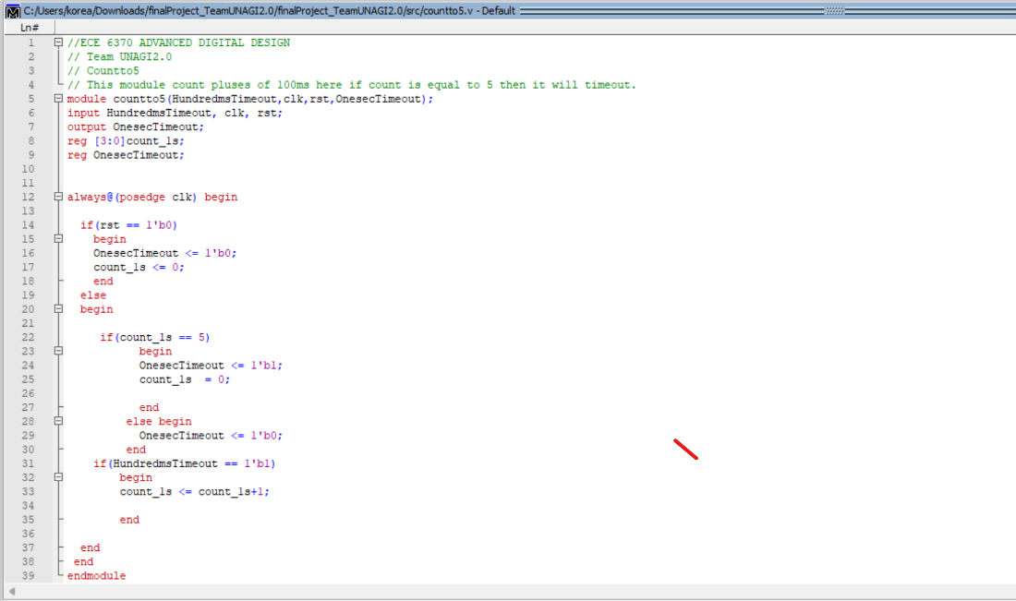

**13.Count to 100:**

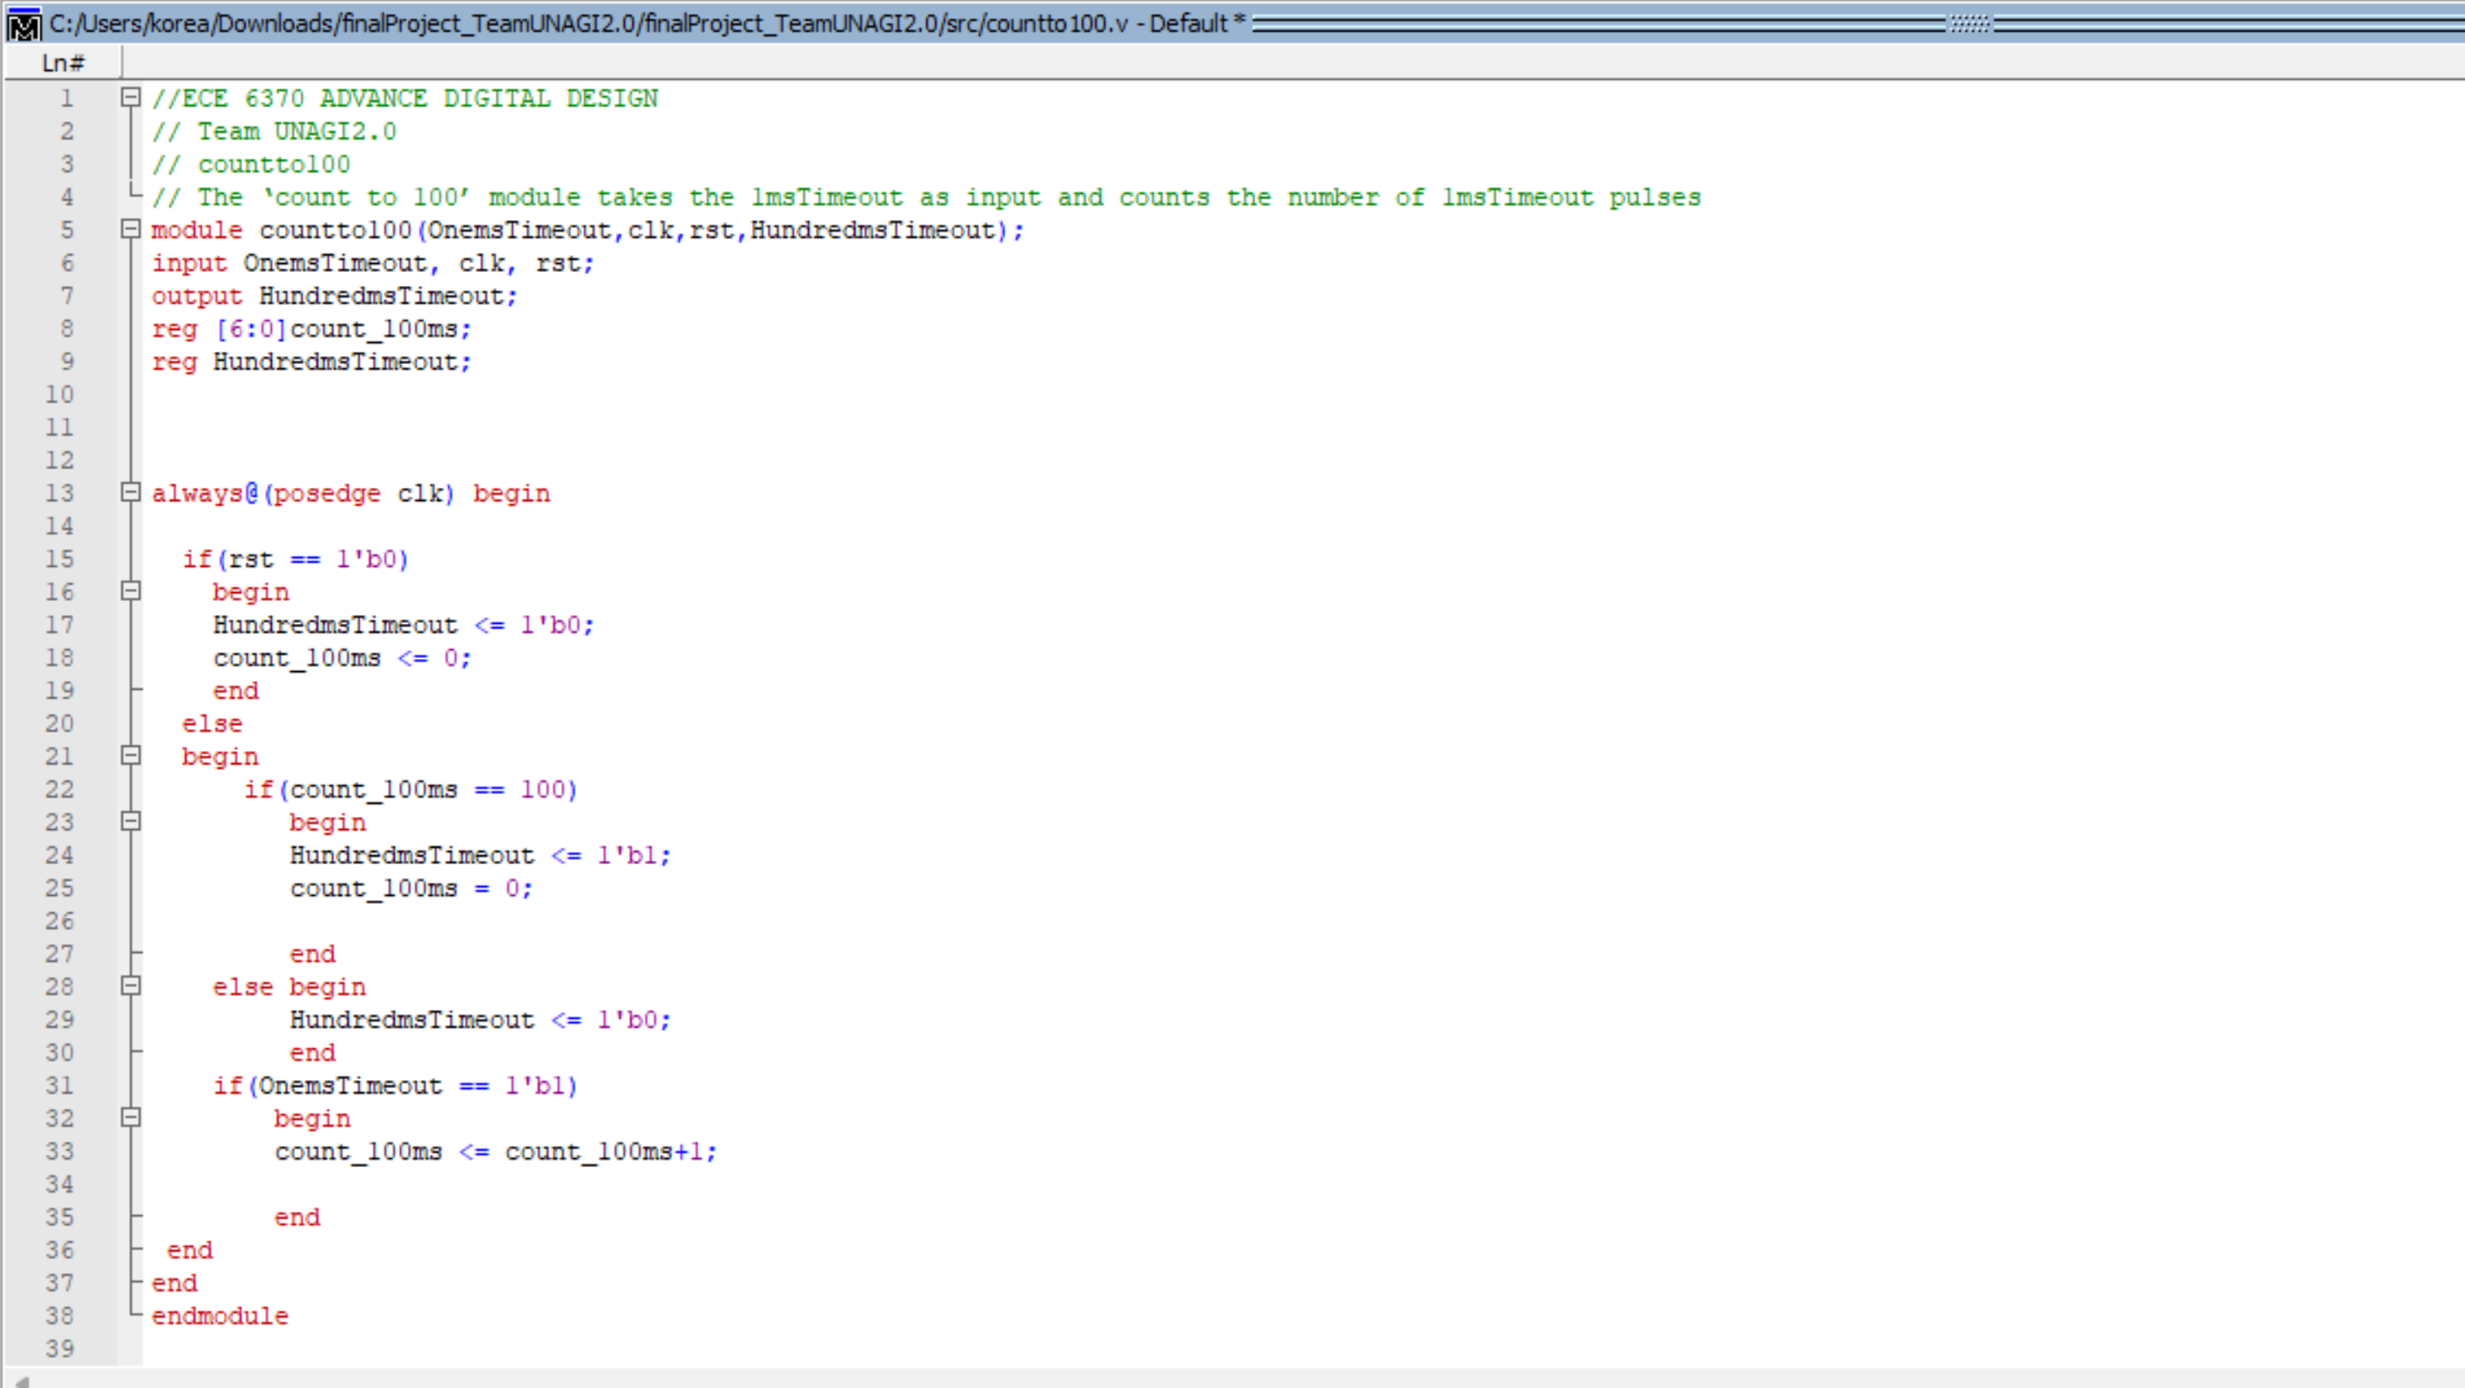

**14.7 Segment:**

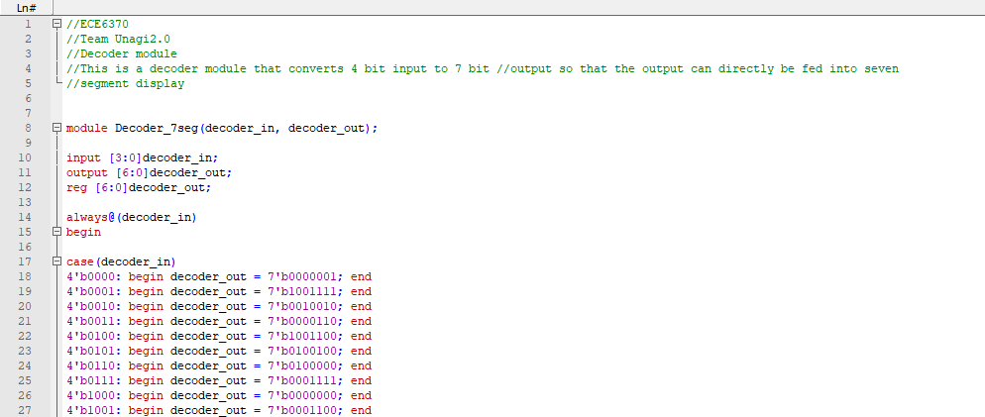

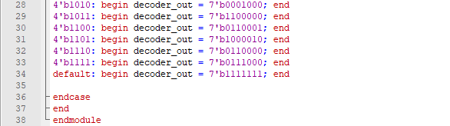

**15.Two Digit Timer:**

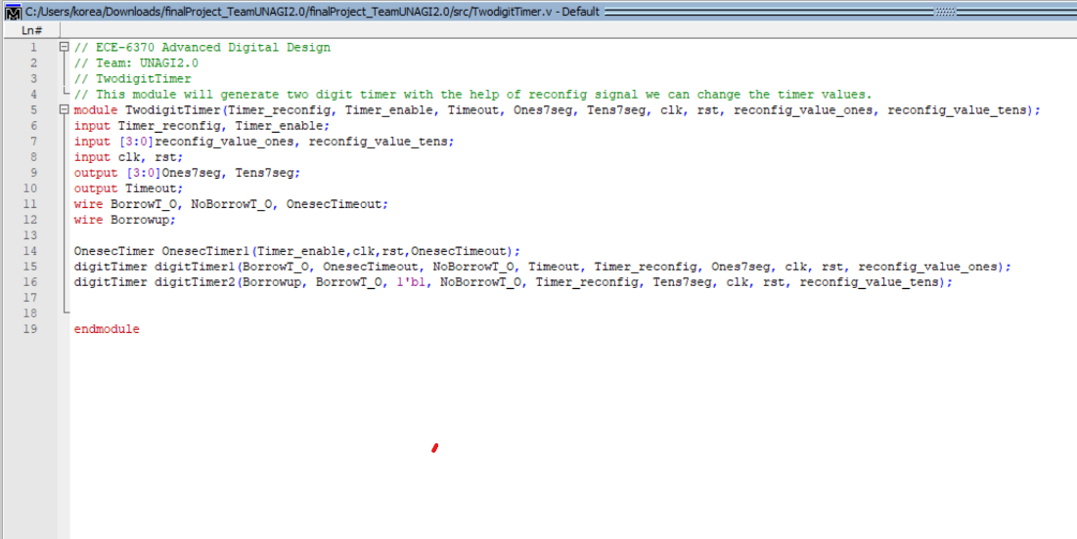

**16.One sec Timer:**

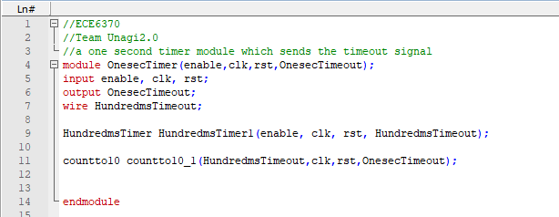

**17.Digit Timer:**

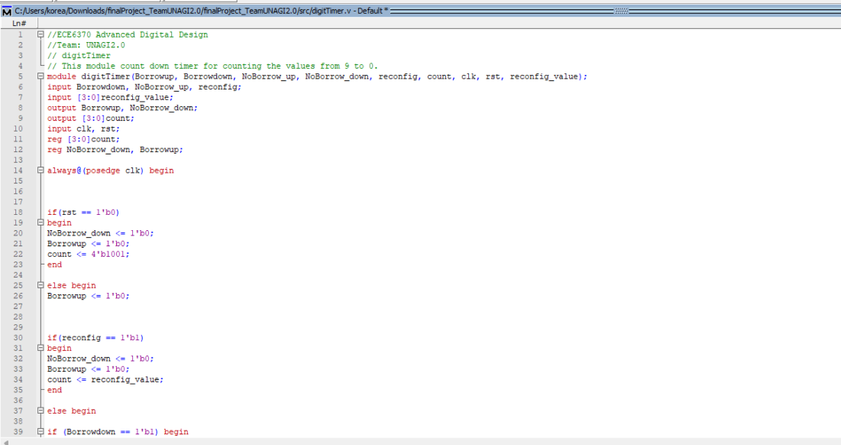

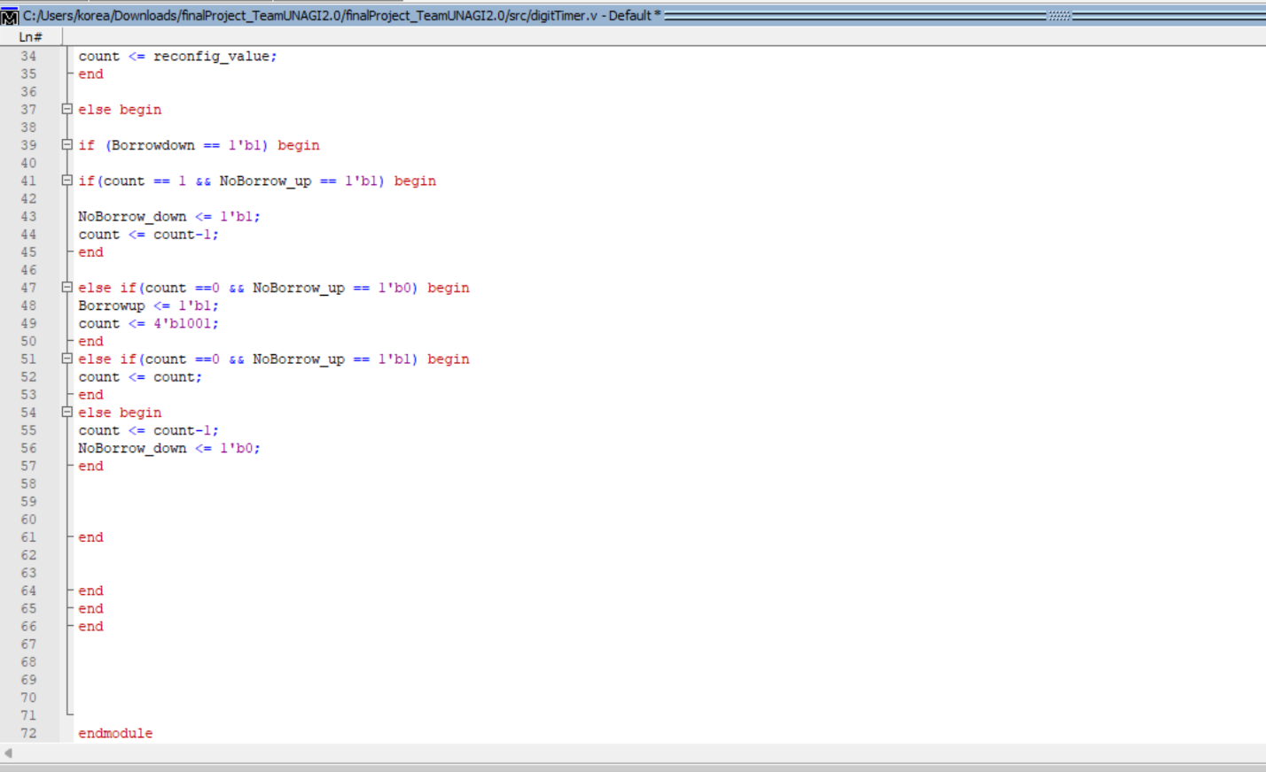

**18.Load Register:**

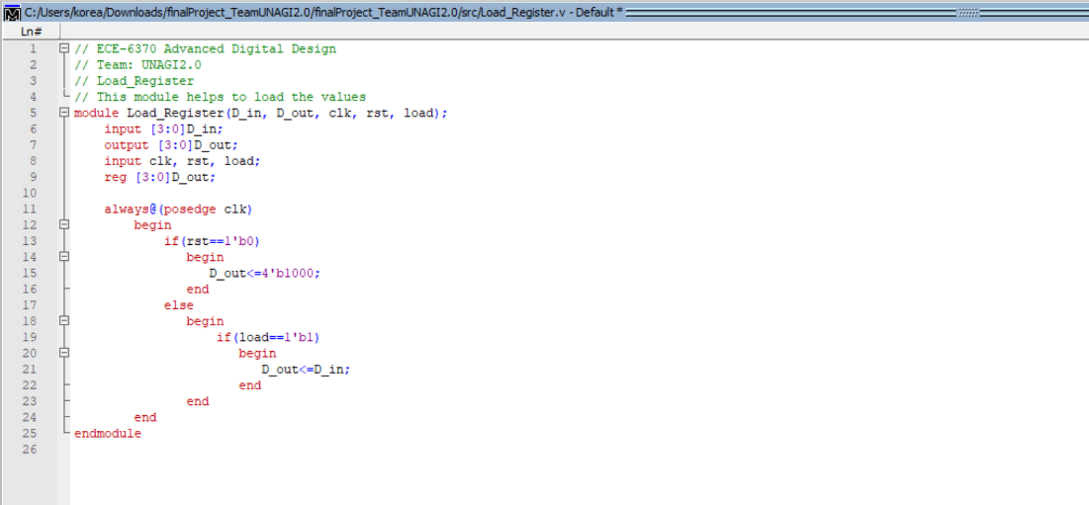

**19.My Mux:**

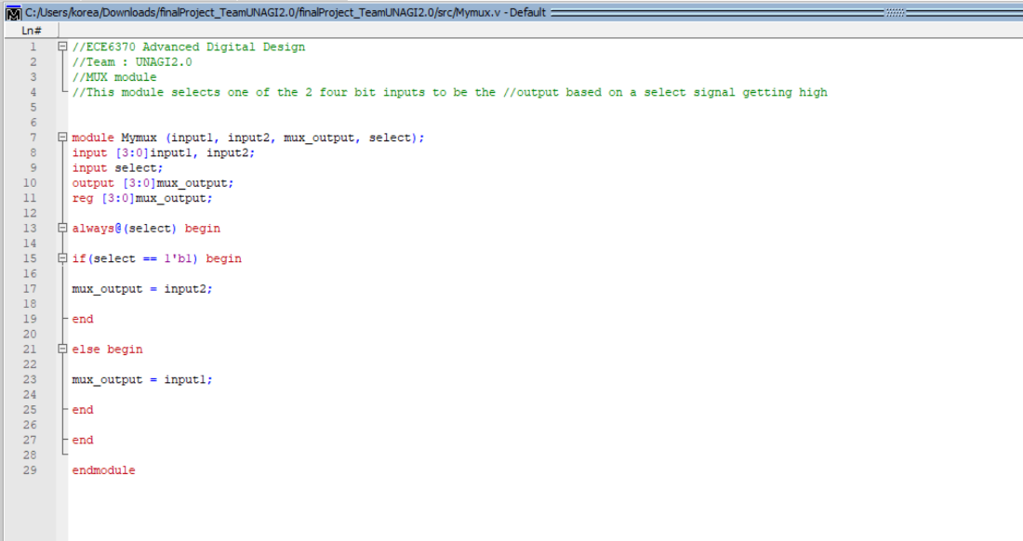

**20.My Mux_1bit:**

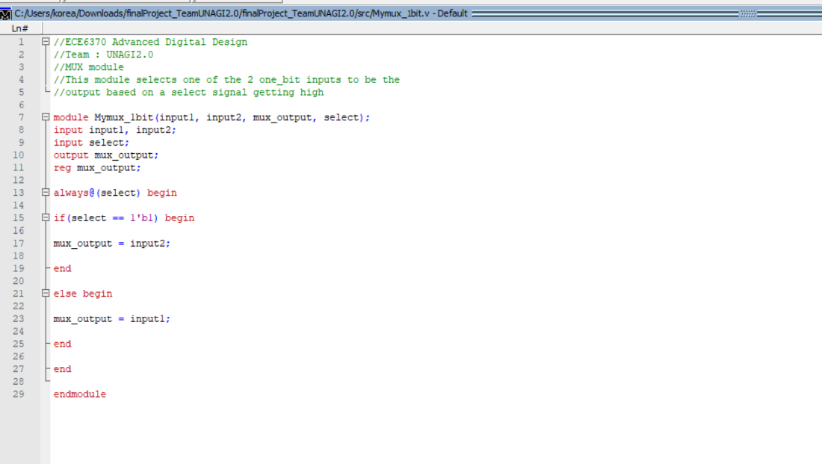

**21.My Mux_7bit:**

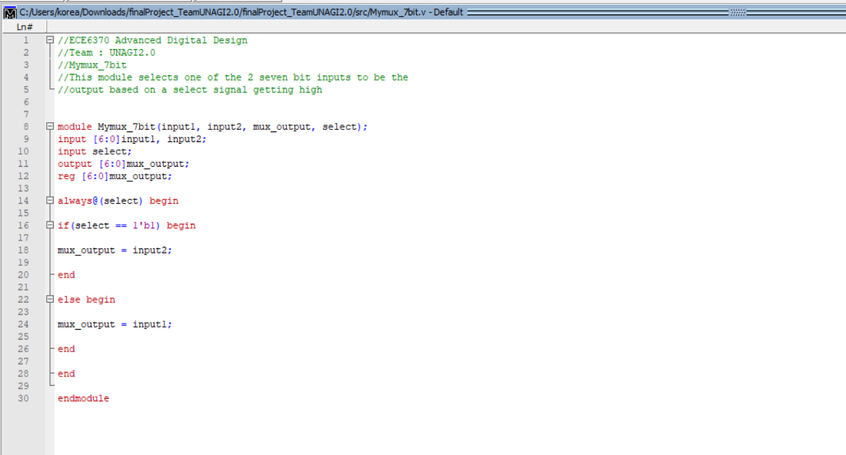

**22.My Mux_10bit:**

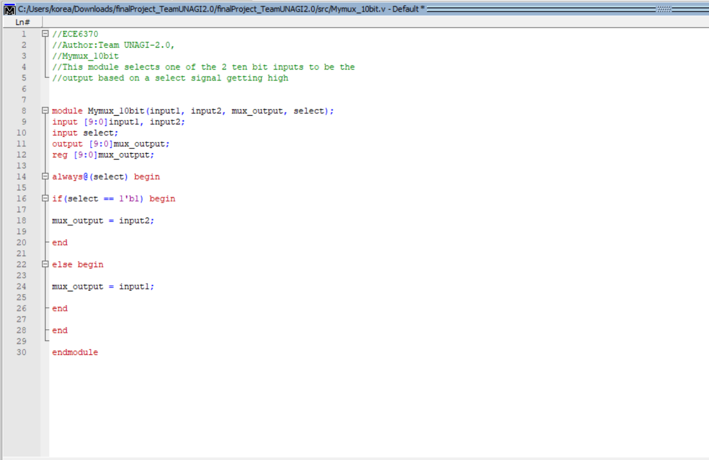

**23.Hundred_ms Timer :**

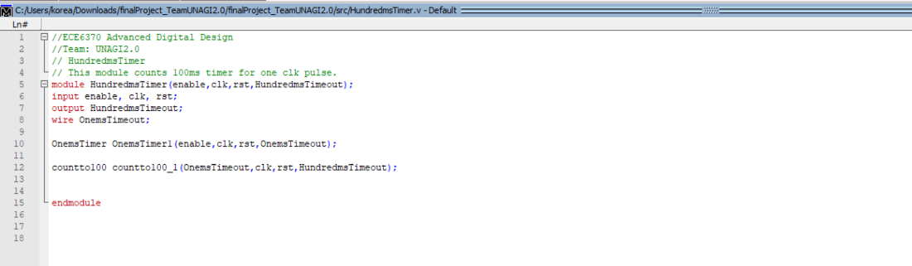

**24.ID Check:**

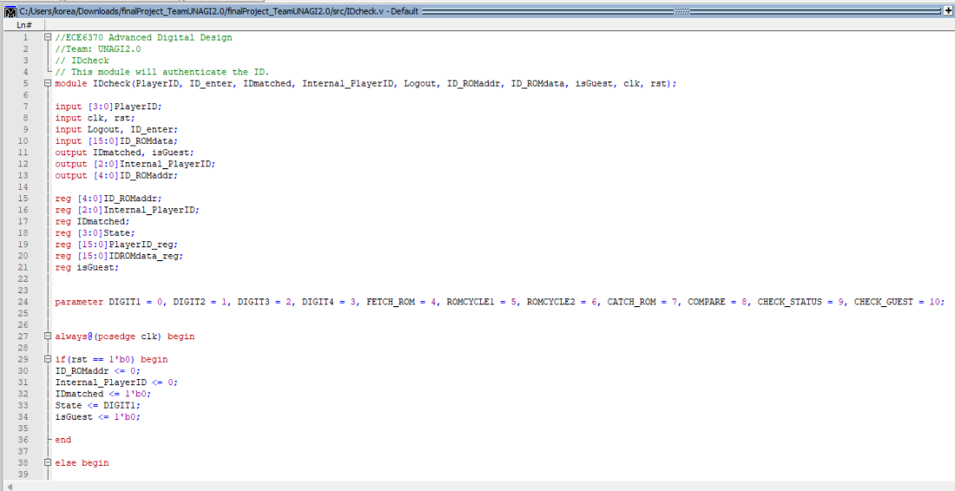

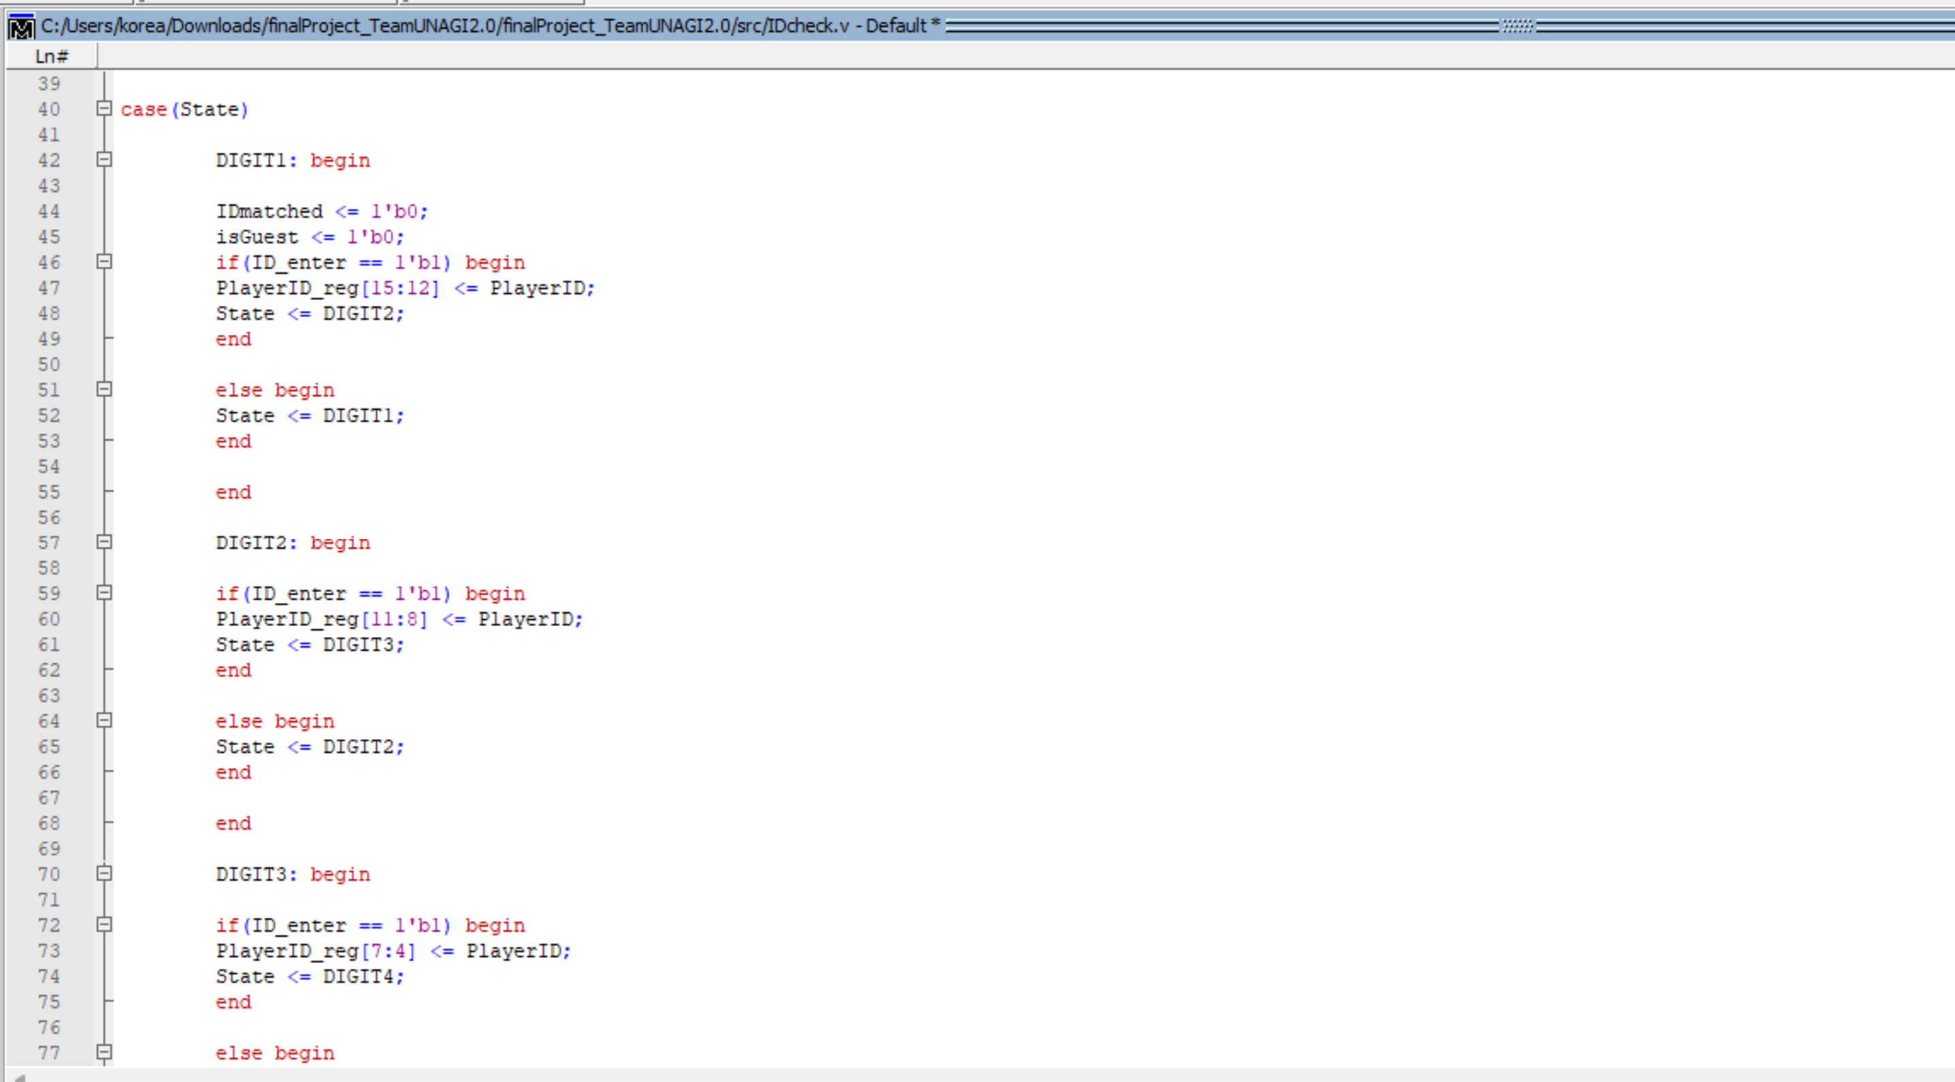

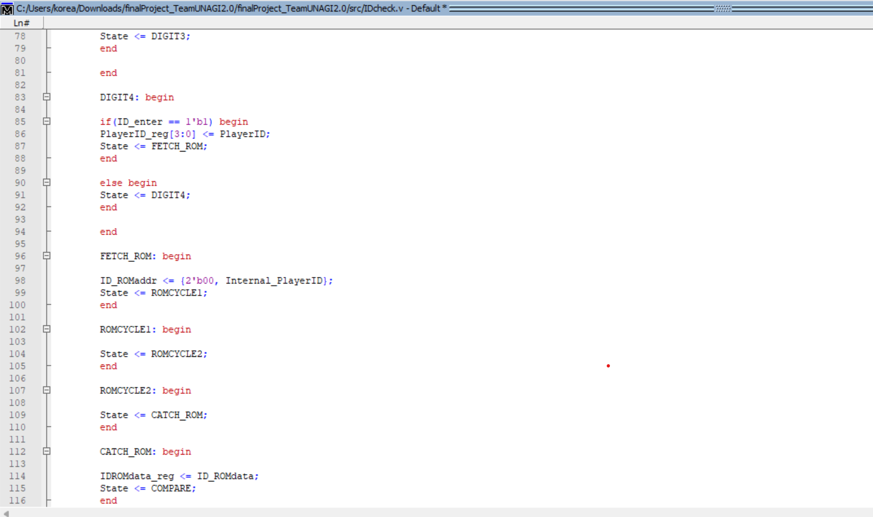

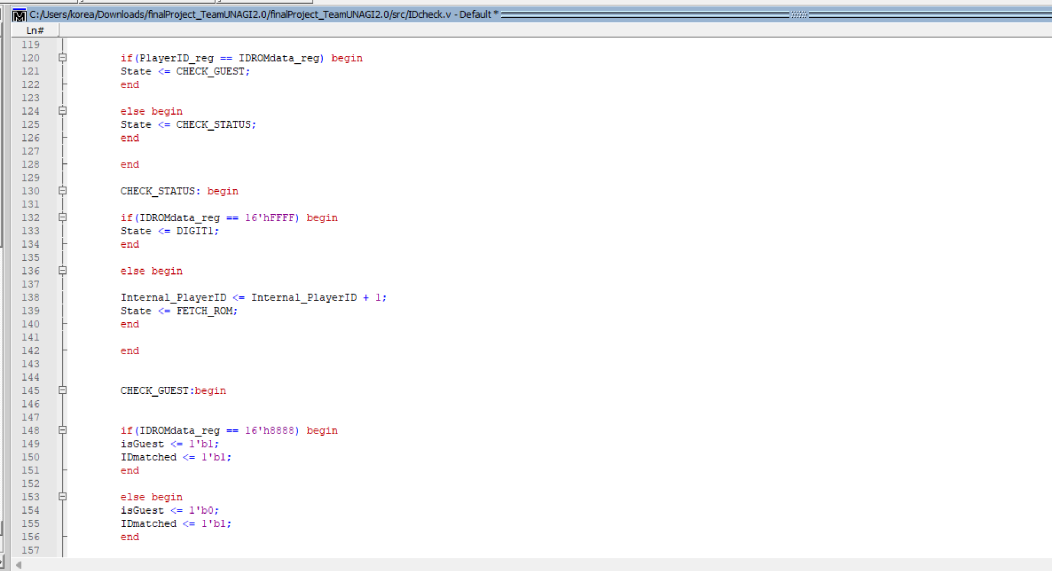

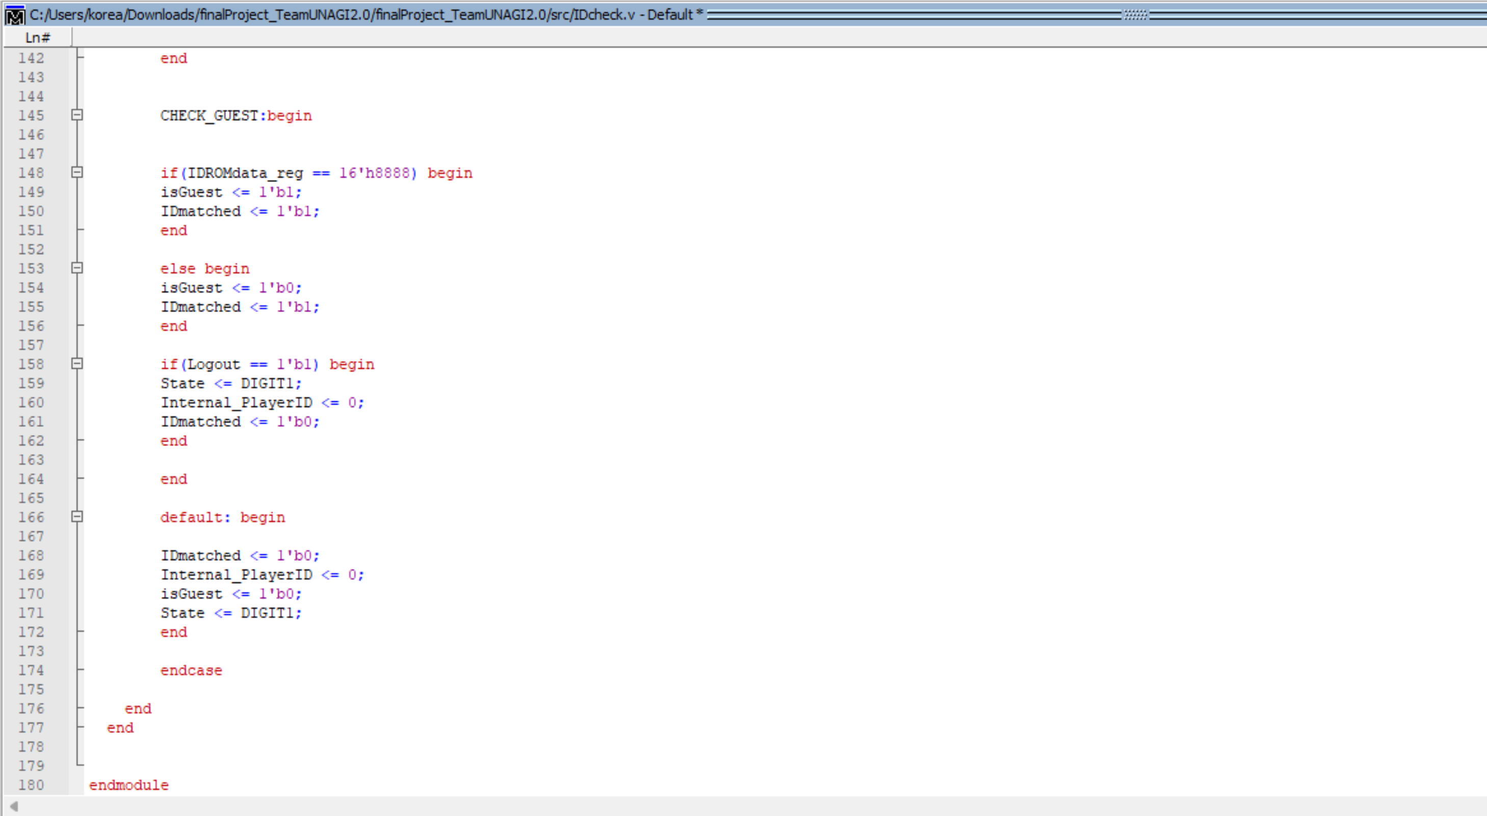

**25.LED blink:**

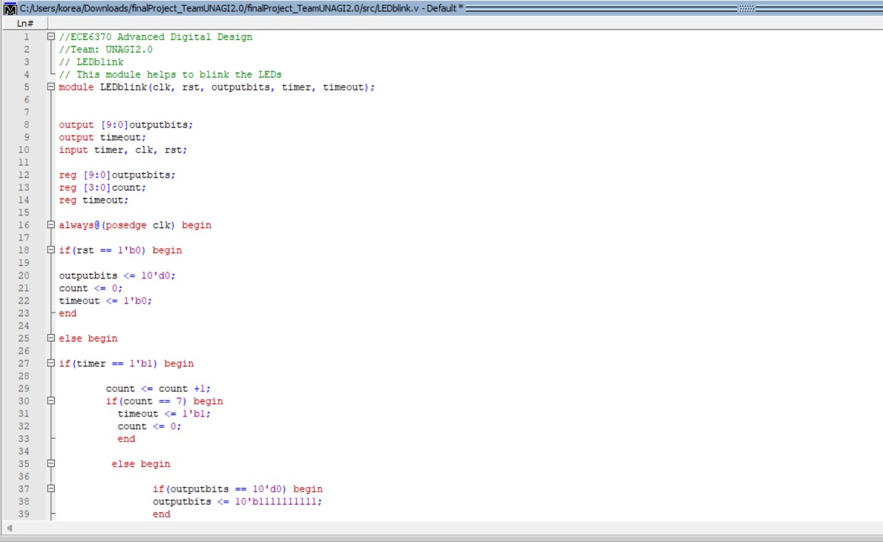

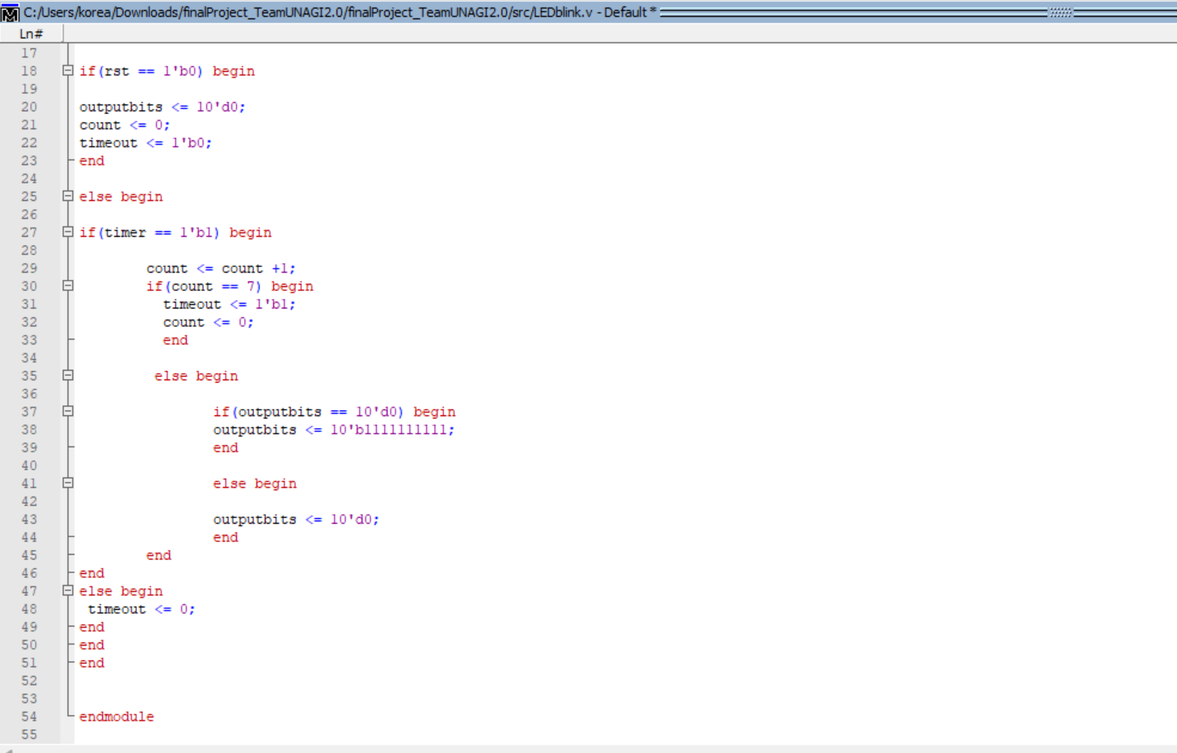

**26.Zero Select :**

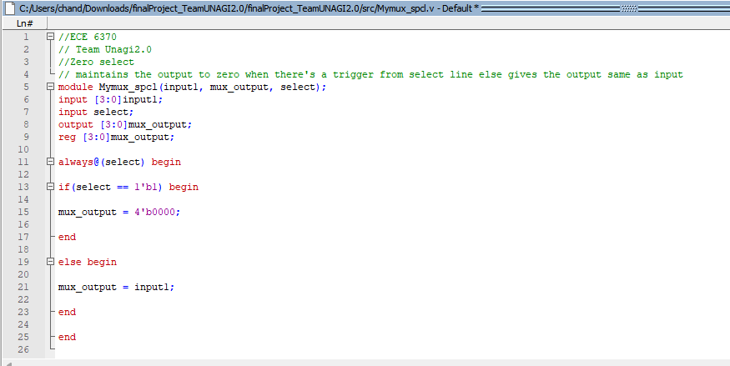

**27.Password Check:**

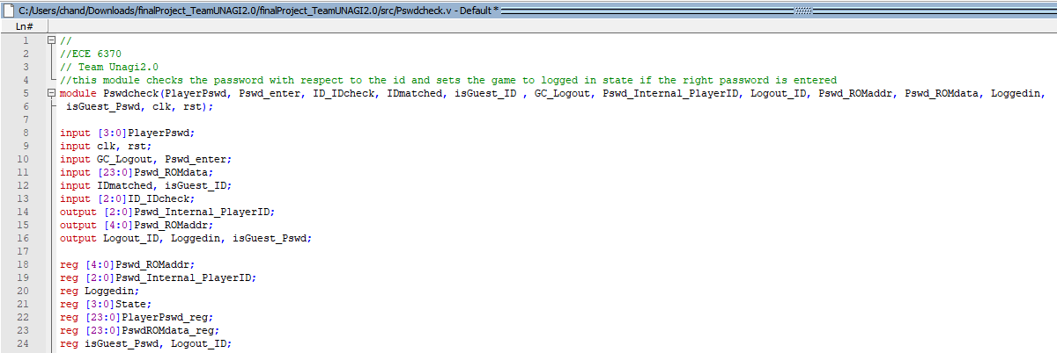

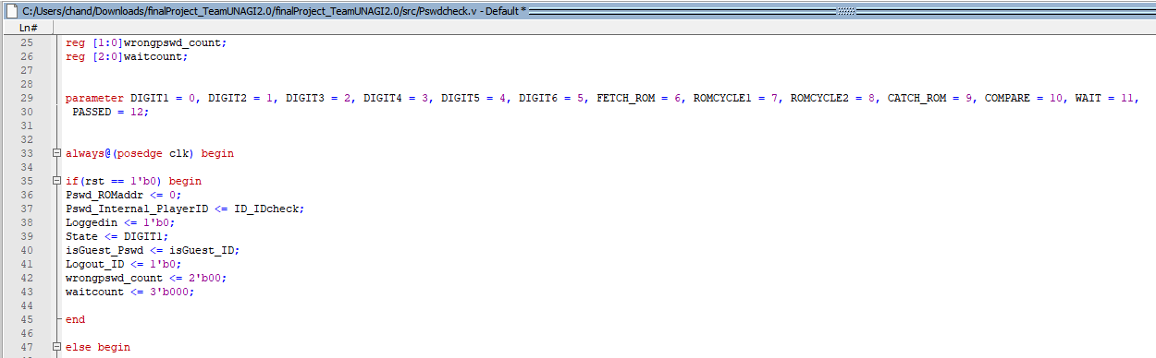

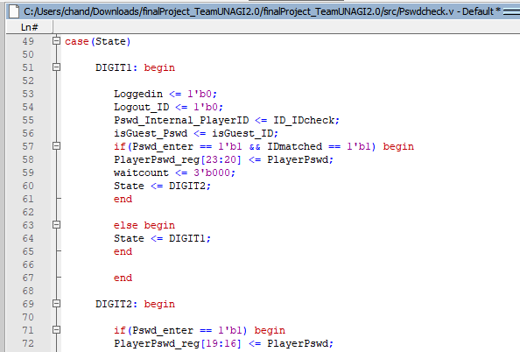

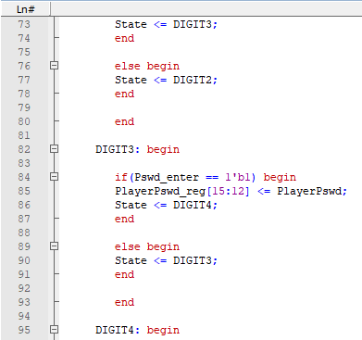

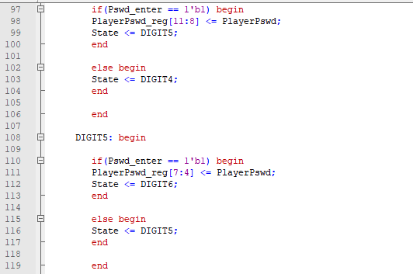

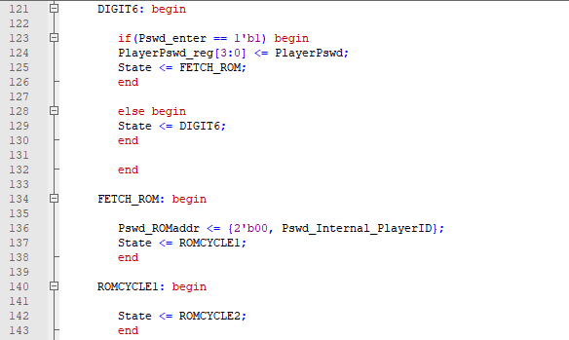

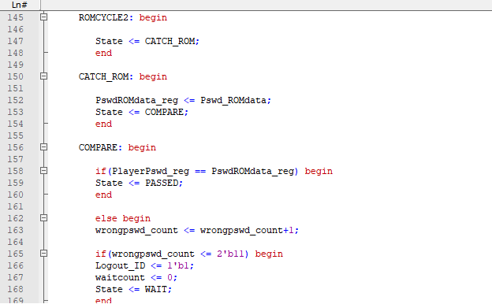

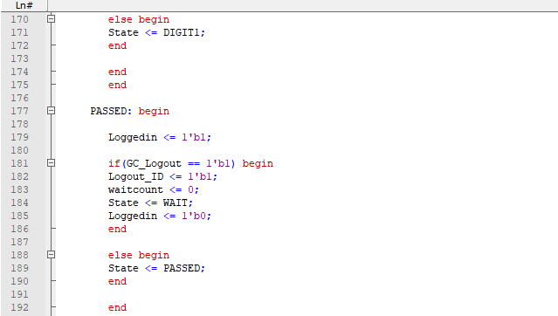

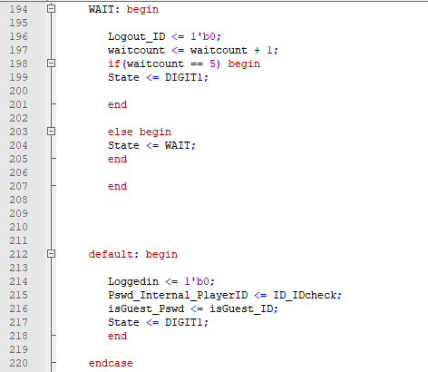

**28.RAM logout:**

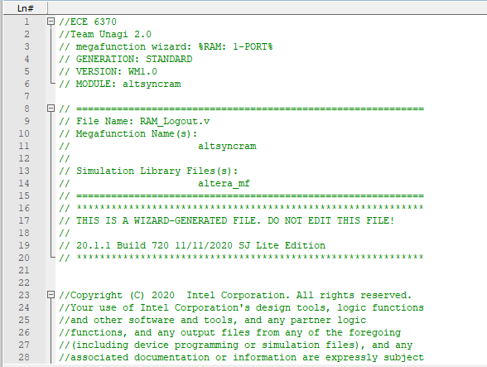

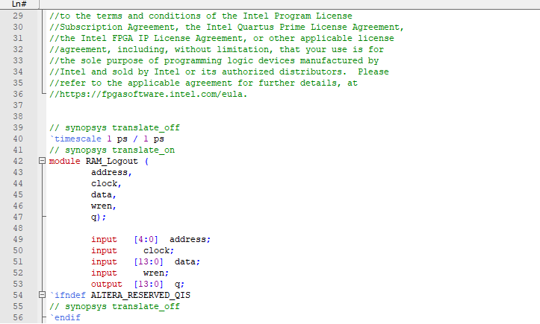

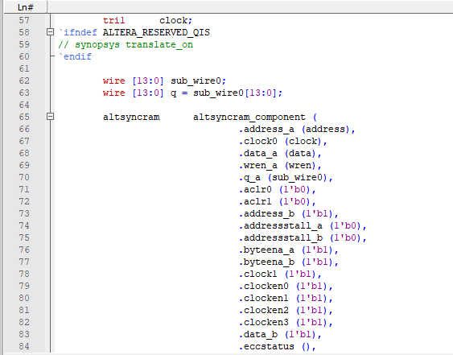

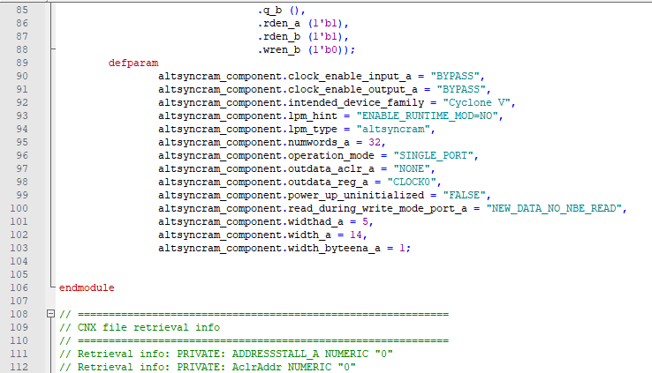

**29.RAM_score track:**

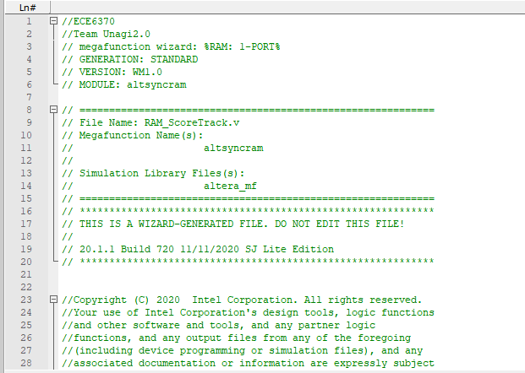

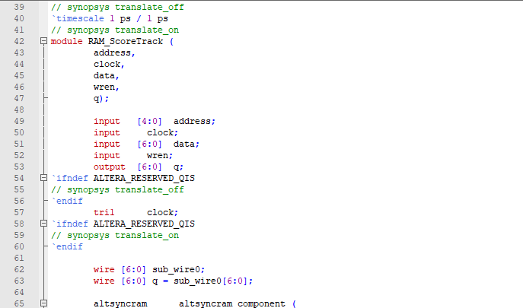

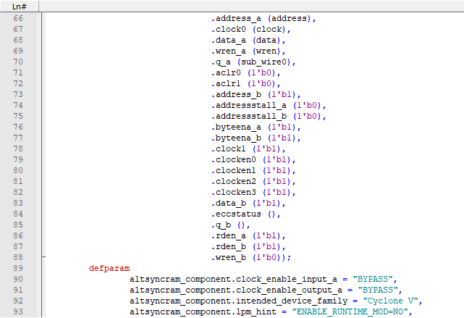

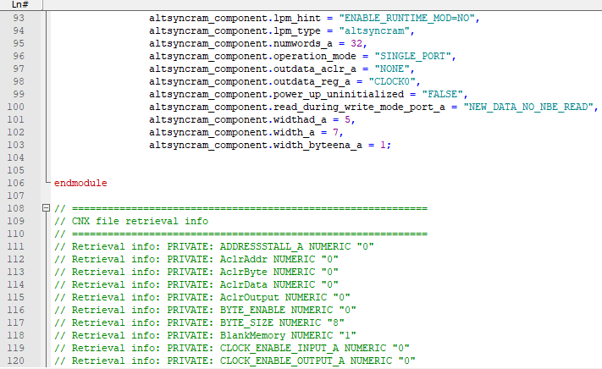

**30.Random Number Generator:**

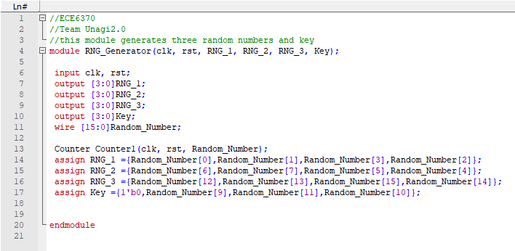

**31.Random Number Generator Top level Module:**

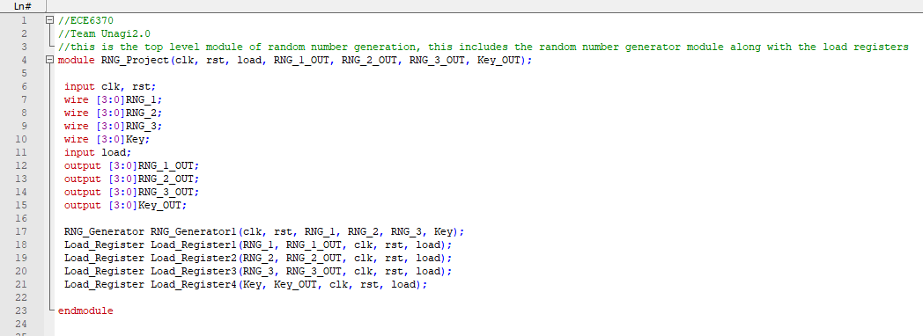

**32.ROM_ID:**

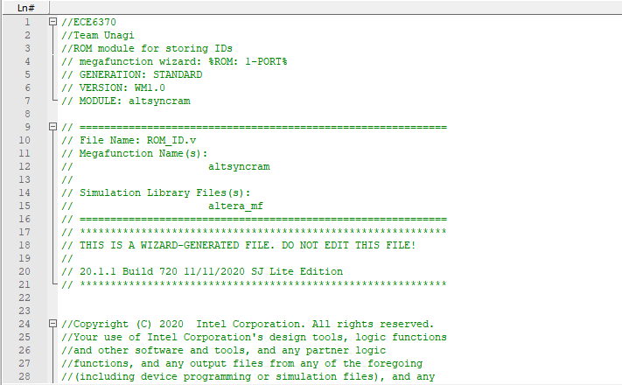

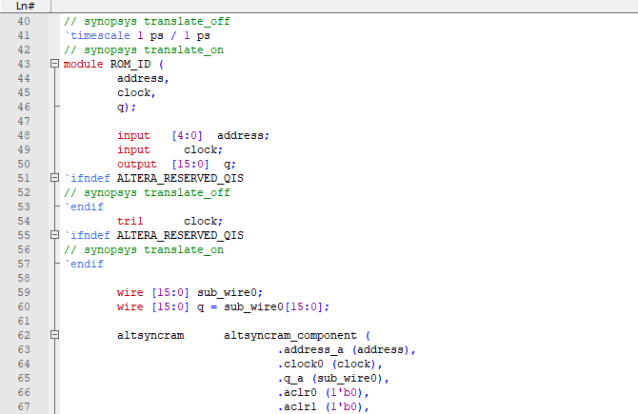

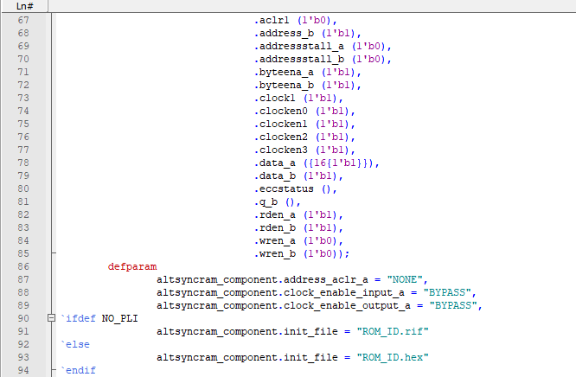

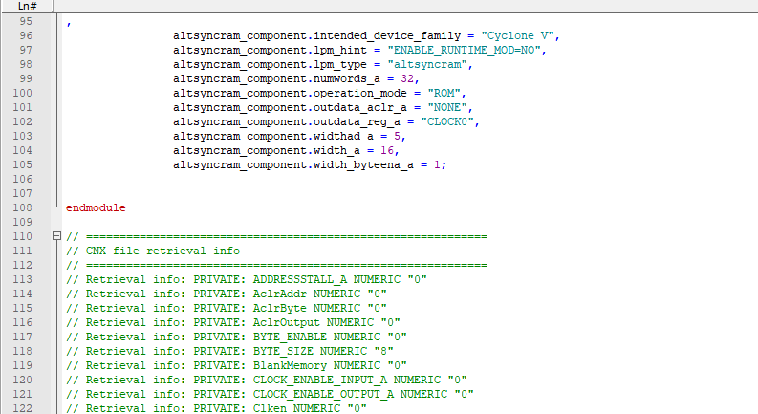

**33.ROM_password:**

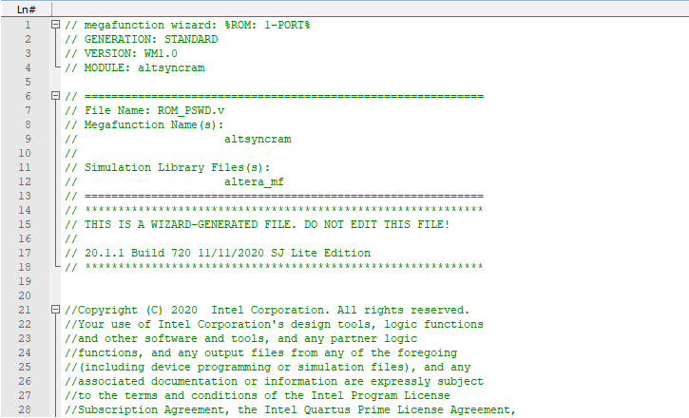

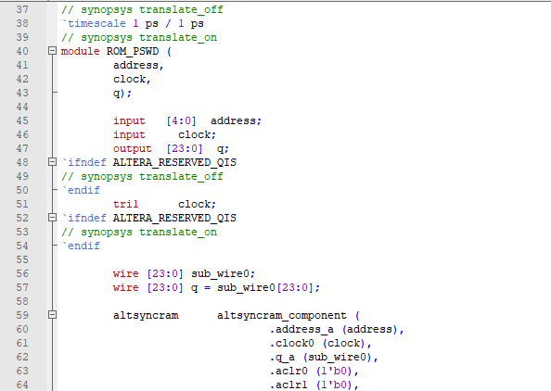

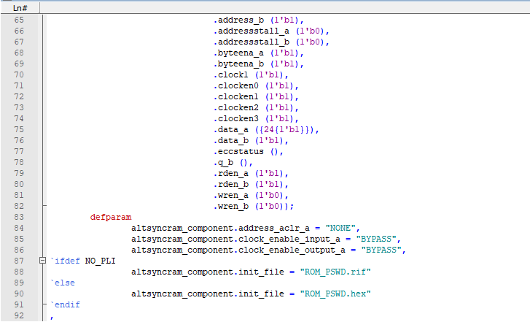

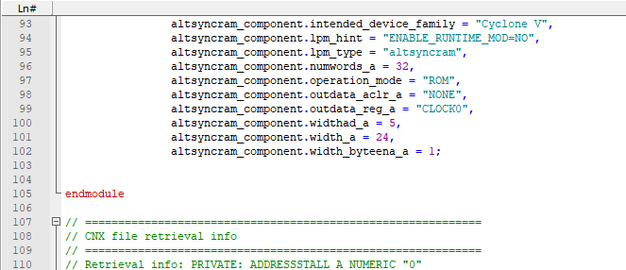

**34.Score Tracking:**

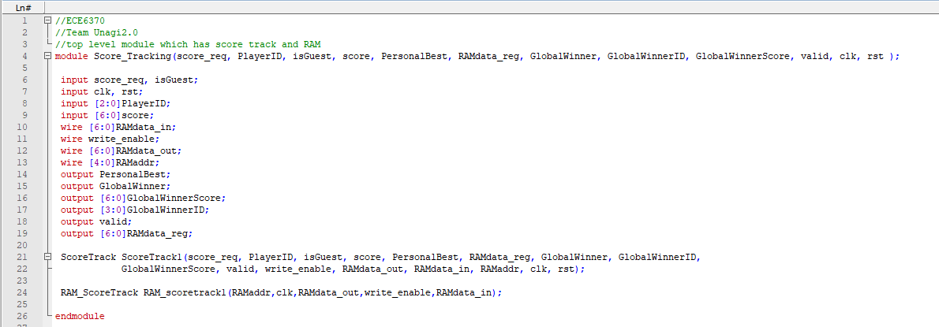

**35.Score Track:**

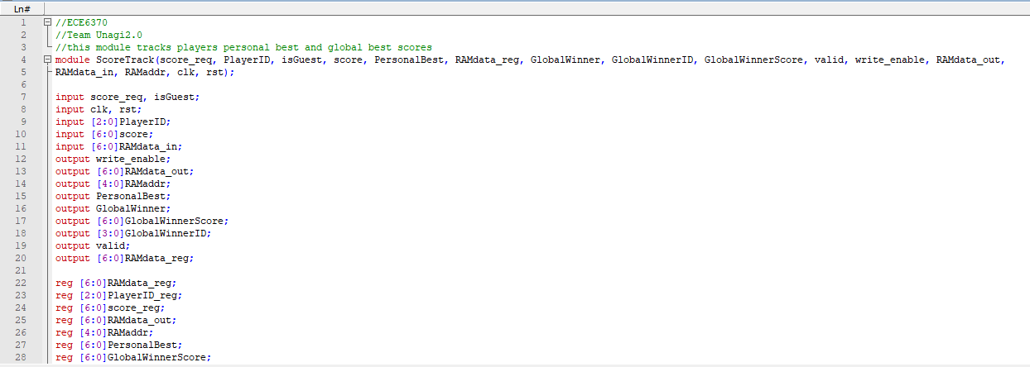

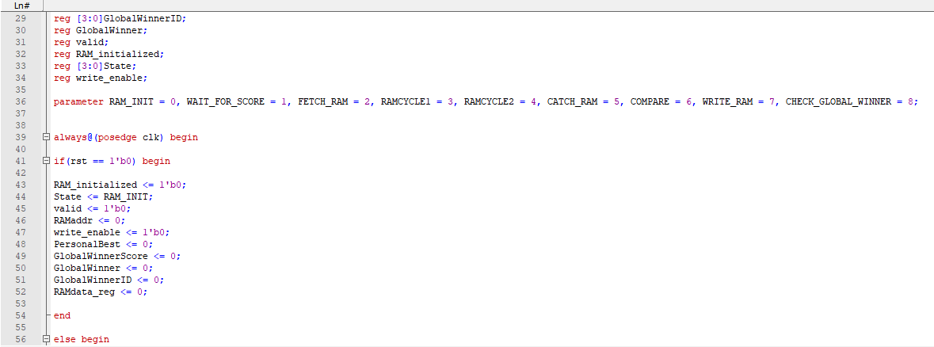

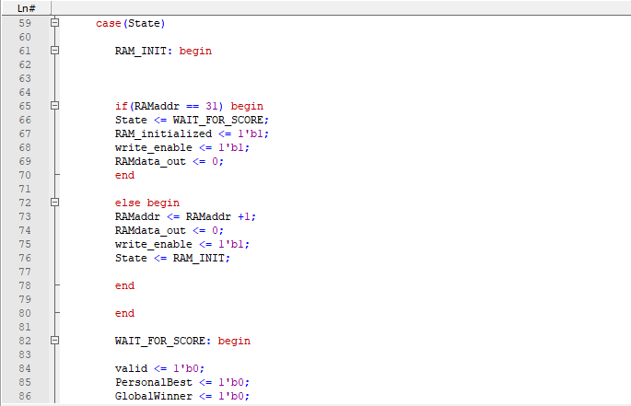

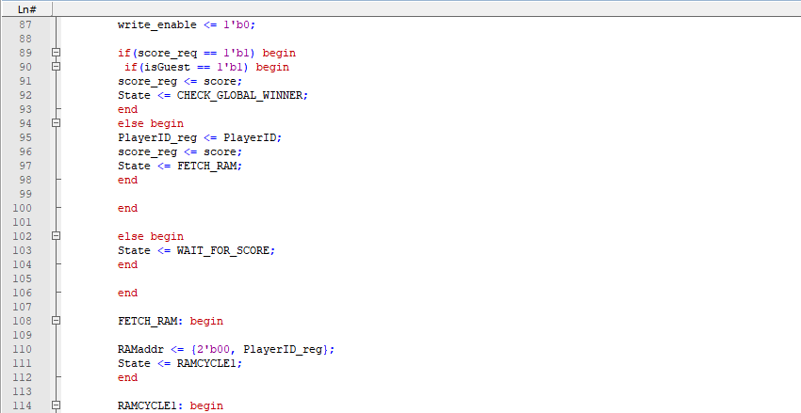

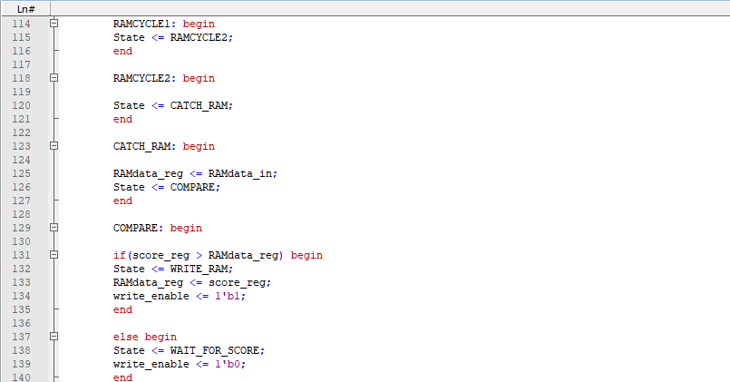

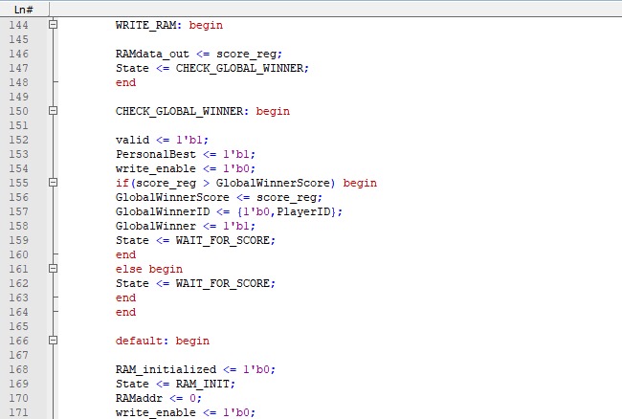

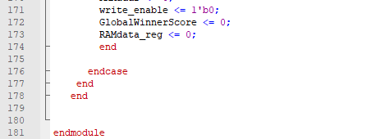

**36.Verify:**

